

User Interface Design | 23CSE209
LAB MANUAL

Submitted to
Name | Dr. Rajkumar Batchu
Department | CSE
Designation | Assistant Professor
Submitted by
Name | PRANAY KINTALI
Roll No | AV.SC.U4.CSE25209
Year/Sem/Section | 1st year | SEM-2 | CSE-C

S. No | Title | Page No. | Remarks
1. | Week-1:1.installation of vs code  2.understanding basics of HTML  3.understanding basics of HTML tags | 7-15
2. | Week2:A. desing a basic web page with headings ,paragraph, table, by adding styles | 16-18
3. | Week3:1.Create class timetable using html elements  2.Create a html web page that should display  syllabus of all the subjects as an image format  and also, the timetable | 19-31
4. | Week4.A. A college wants to collect student details through an online admission form. Design a registration form using only HTML tags (no CSS) with proper labels, table alignment, background color, and borders.  B. A company wants to design a webpage that displays two different forms side by side using iframes. One iframe should display a Login Form and the other should display a Registration Form | 32-39
5. | Week5A. Creating a card layout using <div> t ag consider three cards and a button using html and CSS  B. Navigation using iframe (mini website) upon clicking each buttons the details about that button should be display on the same page  C. Design amrita login page by showing different campus on home page upon clicking on each campus the details about each campus should be display on the same page use html and css to design a stylish webpage. | 40-60
6. | Week6.A. Design a responsive e-commerce application using the grid layout. This application should contain different categories of products such as electronics, clothing, home-appliances, books.  B. Design a responsive e-commerce application using the grid layout. This application should contain different categories of products such as electronics, clothing, home-appliances, books. Based on the category we select corresponding products should be displayed on the sidebar. | 61-77
7. | Week7. Create a Github Repository and upload all related files of lab manual. | 78-83
8. | Week8.A. Create a webpage that displays a square that continuously rotates 360 degree using CSS Animation.  B. Create a ball that moves up and down  continuously using CSS Animation.  C. Create a circle that moves horizontally and rotates at the same time using CSS Animation. | 84-89
9. | Week-9:Create an webpage using html, CSS, java script based on the given conditions:  a) Create a button for each program, based on the button clicked the corresponding program has to be executed and should display the output.  b) The logics for each button include finding an even numbers, odd number, prime or not, factorial of a number, Armstrong or not.  c)Use appropriate designs to display the output. | 90-93
10. | Week-10:10(A): write JavaScript conditional statement  to find the sign of product of three numbers  using functions. Display  analertboxwithspecified sign  10(B) write a java script conditional  statements to sort 3 numbers using functions  display an alert box to show the result  10(C) write a java script conditional  statement to find largest of find largest of five  numbers using function and onclick event  . display an alert box to show the result  10(D) write a java script for loop that will  iterate from 0 to 15. For each iteration, it will  check if the current number odd or even, and  display a message on screen  10(E): write a java script program to read 6  subject’s marks from the student then  computes the average marks of students then,  this average is used to determine the  corresponding grade. | 94-102
11. | Week-11:  A website requires users to enter a username. The  system should display a message while typing if the  username is less than 5 characters.  B. A registration form should validate email format before submission. If invalid, the form should not be submitted.  C. A system should check password strength while typing and display whether it is weak or strong.  D. A form should validate a mobile number when the user leaves the input field. The number must be exactly 10 digits.  E. Design an HTML page, such that the registration form must validate: Name (not empty) Email (valid format) Password (minimum 6 characters) | 103-110
12. | WEEK-12:  Steps to install and set up electron | 111-126

WEEK | 1

1.Aim: To Download and Install VS code
Procedure:

Step-1: Visit the official VS code website to get the downloadable file.

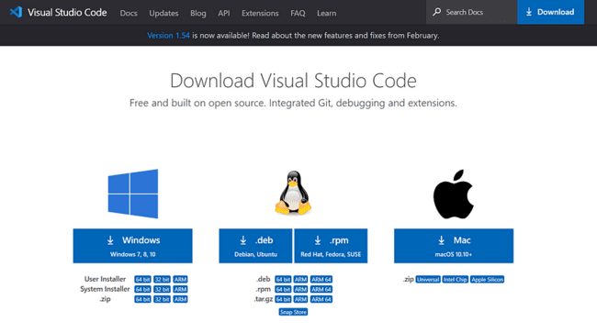

Step-2: Click on the download Option based on the Operating system.

Step-3: Click on the downloaded file to Install.

Step-4: Accept the agreement and click on “Next”.
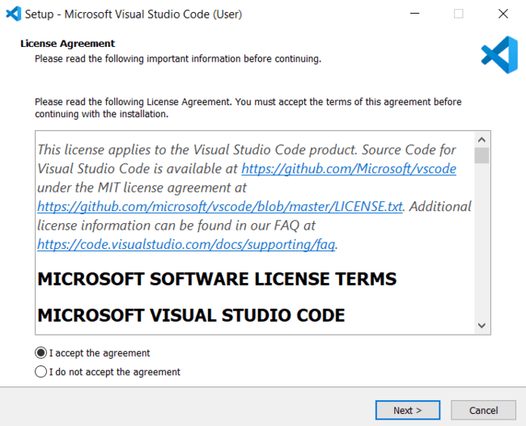

Step-5: Select a folder. Click “Next”.
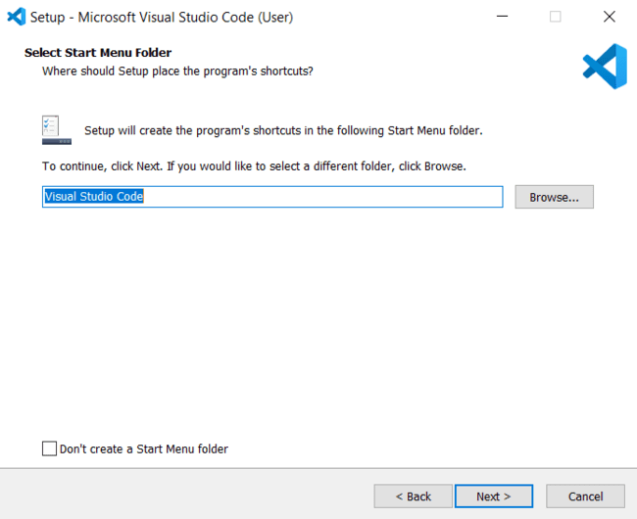

Step-6: Select the required options and click “Next”.
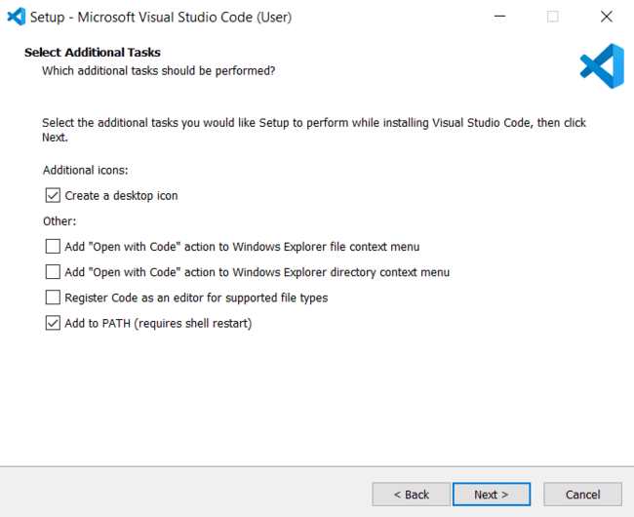

Step-7: Select “Install”.

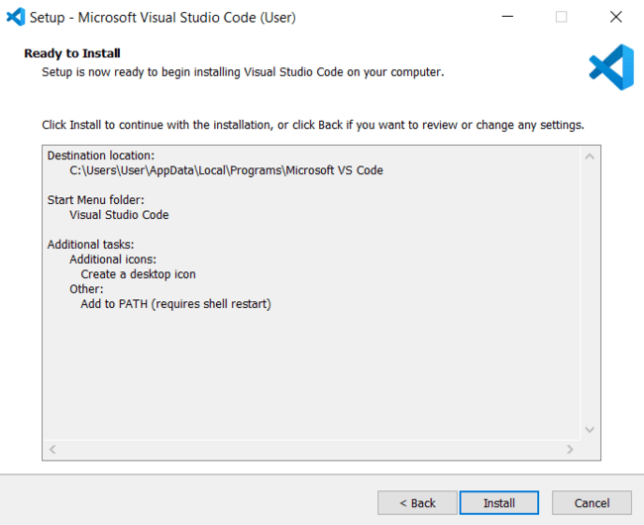
Step-8: Click “Finish” after installing successfully.

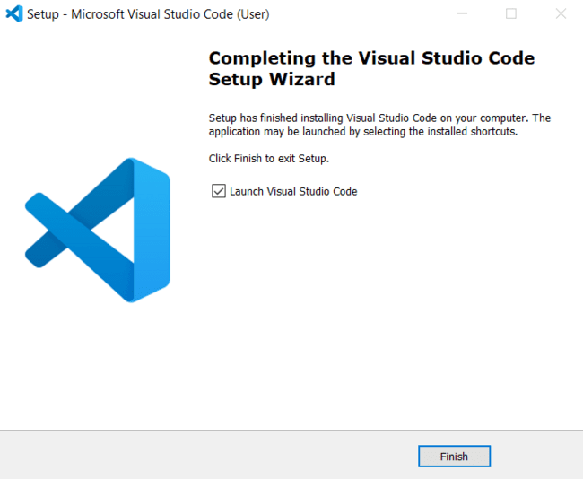

Step-9: Open VS code and go to Extensions tab on the left side panel, search for “Open in browser” extension and download that extension.
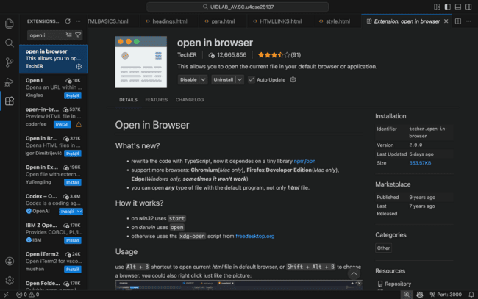

2.Aim: To understand the basic structure of HTML
Program:
Input:
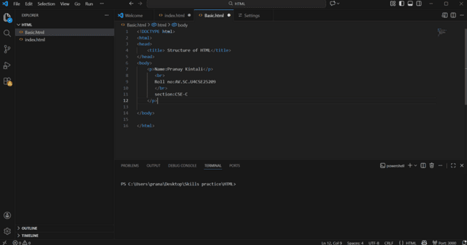
Output:
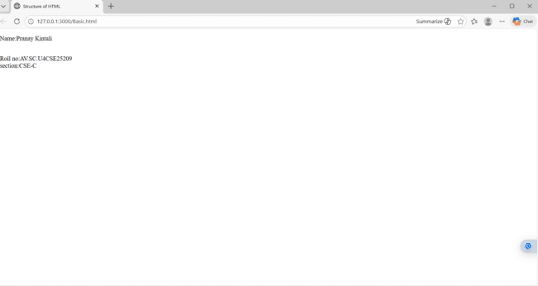

Explanation:
<!DOCTYPE html>
This tells the browser that the document is written in HTML5.

<html></html>
This is the main element of the HTML document.
Everything on the webpage goes inside this tag.

<head></head>
The head section contains meta information about the page.
Things here are not shown directly on the webpage.
This contains information that is applied to whole webpage like images or colour to the web page.

<title></title>
Sets the title of the webpage.
This text appears on the Browser tab.

<body></body>
This is the visible part of the webpage.
Everything the user sees (text, images, buttons, forms, etc.) goes here.

3.Aim: To understand the basic html tags
Program:
Input:
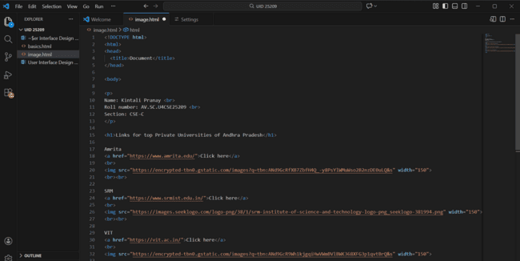
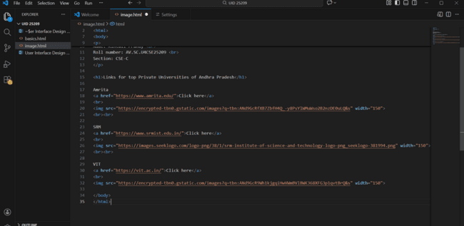

Output:
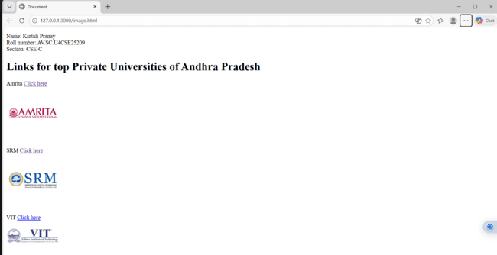

Explanation:

. <head> : the <head> element will contain meta data about the HTML web page
. <title> : the <title> element specifies a title for the HTML Page
. <body> : the <body> element contains all visible content all visible content like text ,
image , links , tables , etc
. <h1> : the <h1> element defines a large heading
. <p> : the <p> element defines a paragraph
. <br> : the <br> element defines a line break. It is an empty tag with no end tag
. style : the HTML style attribute is used a add style to an element such as colour , font ,
size and more
. <img> : the <img> tag is a fundamental HTML element used to embed an image into
web page
. <a> :the HTML <a> element stands for “anchor”, is used to define hyper link
. href : the HTML href attribute is used to add link to the html web page

Week | 2

2.A)Aim : desing a basic web page with headings ,paragraph,table, by adding styles
Program:
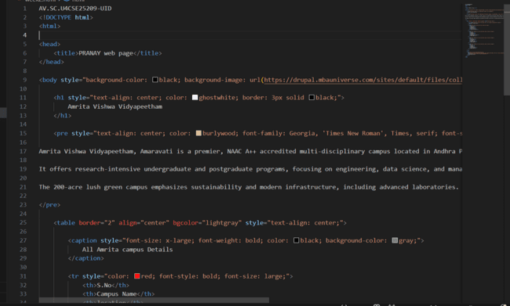

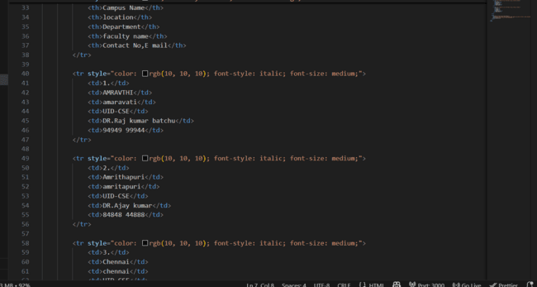

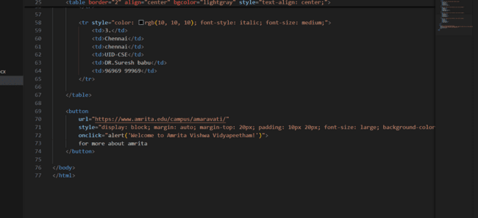

OUTPUT: 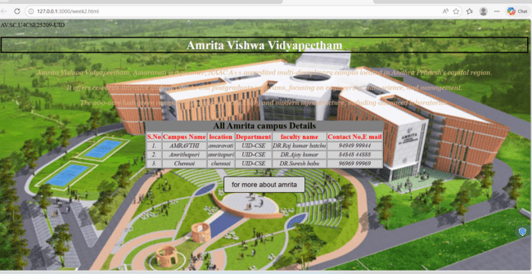

Explanation :
. <DOCTYPE html> : the <!DOCTYPE html> element tells the web browser that this an HTML documen
or this is the latest version of HTML
. <html> : the <html> element is the root element of an HTML web page
. <head> : the <head> element will contain meta data about the HTML web page
. <title> : the <title> element specifies a title for the HTML Page
. <body> : the <body> element contains all visible content all visible content like text , image , links ,
tables , etc
. <table>: the element <table> is used to create a table
. <tr>: the element <tr> creates a new row in the table
. <th>: the element <th> create a new heading inside the table
. <td>: the element <td> fill the columns in the row
. <button>: the element <button> is used for button .
The style attribute is used to add style the elements in the html webpage and url attribute for adding the url or link to the button

Week-3
3.A).Aim : to create a time table using html by using tags like
<table>,<td>,<th>,<tr>,and using style attribute in it
Program :

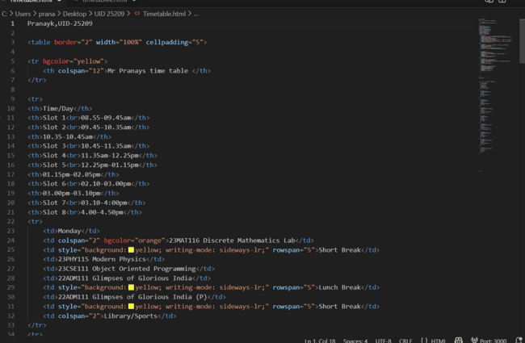
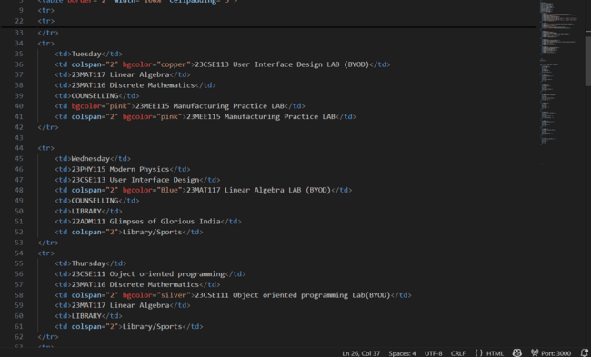

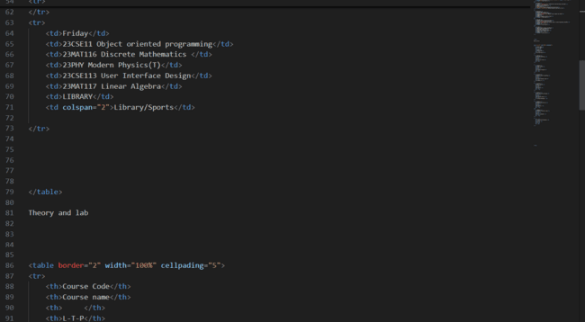

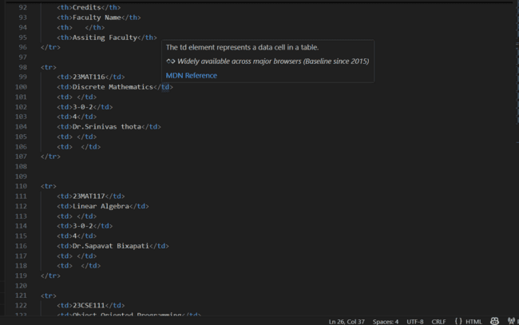
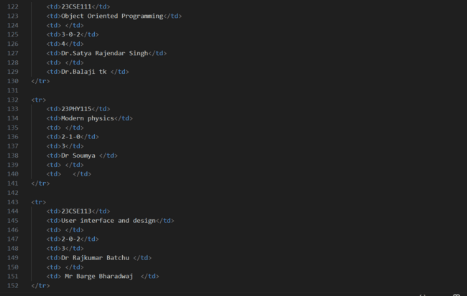
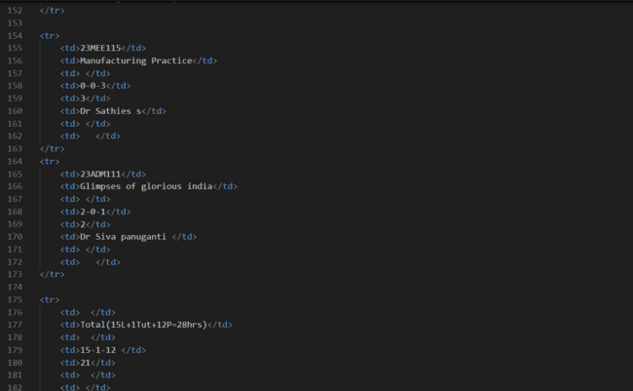
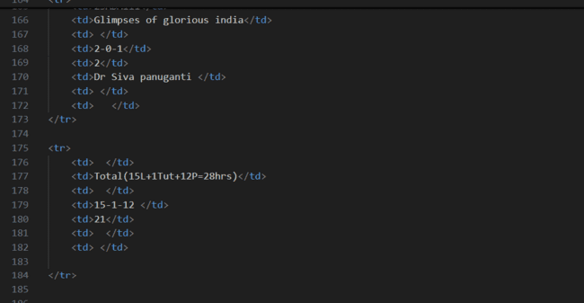

OUTPUT
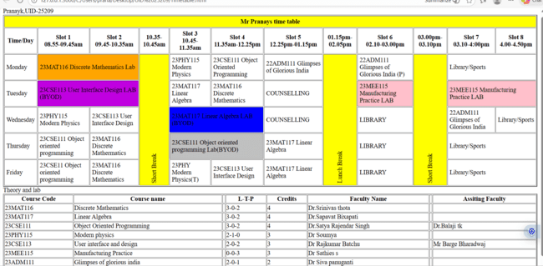

Explanation :
we use this tags in addition to the above tags that we used in other programs
<h> : we used <h> element for heading

<p> : we used <p> element for the paragraph

<table>: the element <table> is used to create a table

<tr>: the element <tr> creates a new row in the table

<th>: the element <th> create a new heading inside the table

<td>: the element <td> fill the columns in the row
And we used colspan and rowspan to combine two rows or colums in the table. And we used the style attribute in both the td and tr tags to get the text in vertical way and colour for the blocks and alignment of text.

2.Aim: to create the timetable with the respective syllabus at the end of the page.
In this we use the combined form of the week-1, 3rd one and week-2 1st one
Program : 









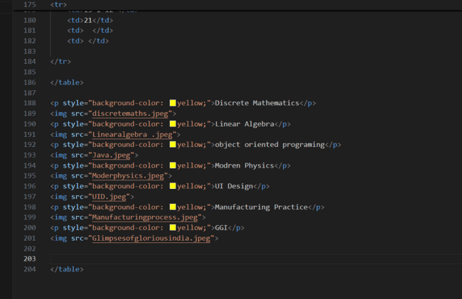
Output:

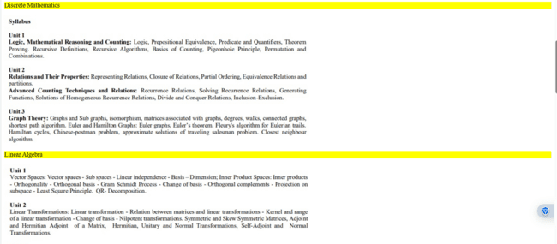
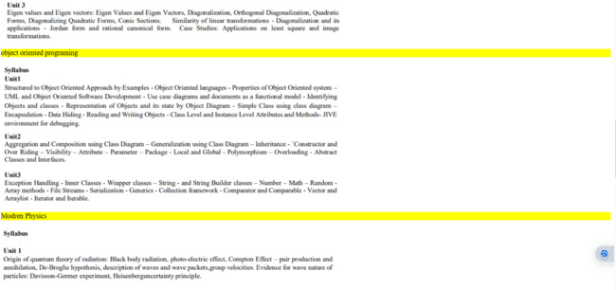
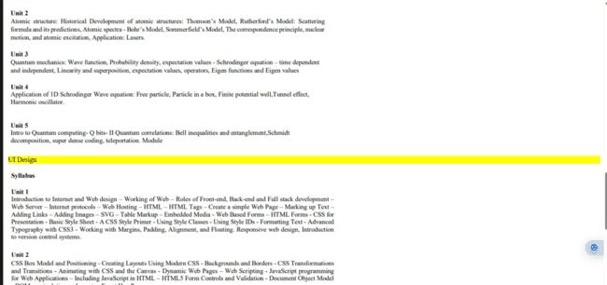

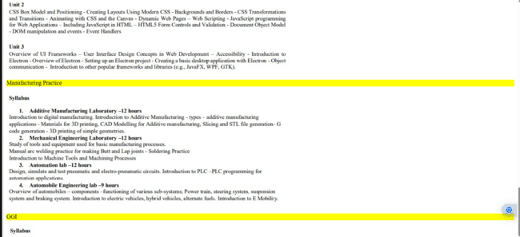
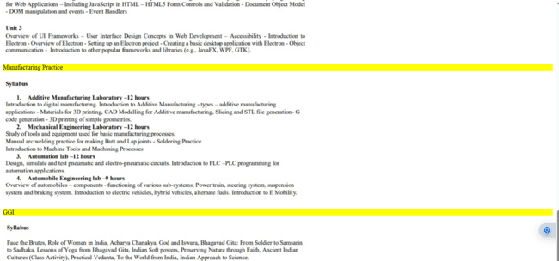

Explanation:
In this we use the combined form of the week-1, 3rd one and week-2 1st one . In detail we use the table tags that we used in week-2, 1st program and the image elements from week-1 3rd program by combining both of those tags we get this .
<h> : we used <h> element for heading

<p> : we used <p> element for the paragraph

<table> : we used <table> element for the creation of the table

<tr> : we used <tr> element for creation of row in the table

<td> : we used <td> element for creation of table details

<th> : we used <th> element for creation of table headings

<img> : we used <img> element for adding the images into the web page

And we used colspan and rowspan for combining rows and coloums and scr attribute for adding the image link and we also used style attribute for the colurs and the vertical text and alignment of text.

Week – 4:
4.A)Aim: Design a registration form using only HTML tags (no CSS) with proper labels, table
alignment, background color, and borders.
Program :
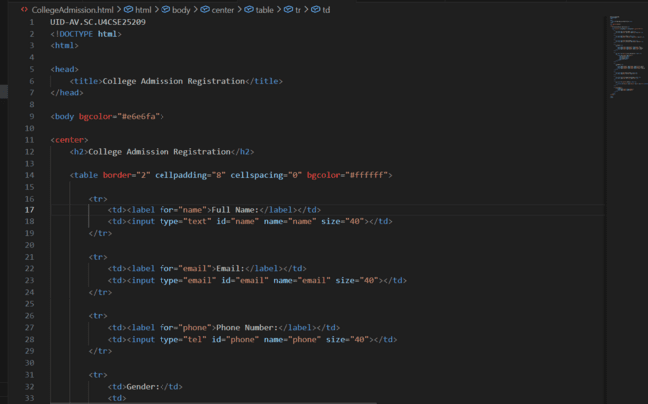

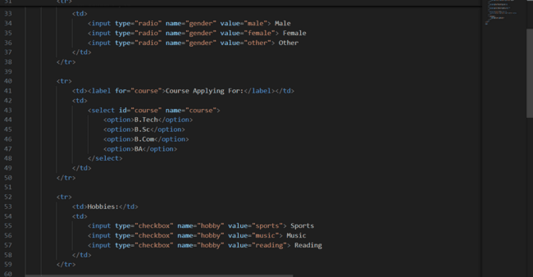
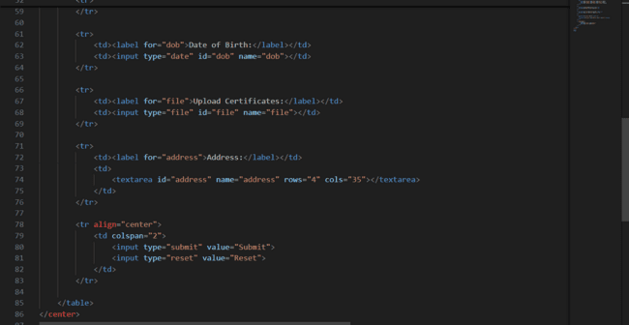

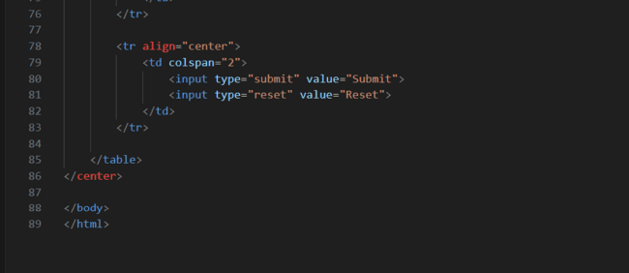
OUTPUT:
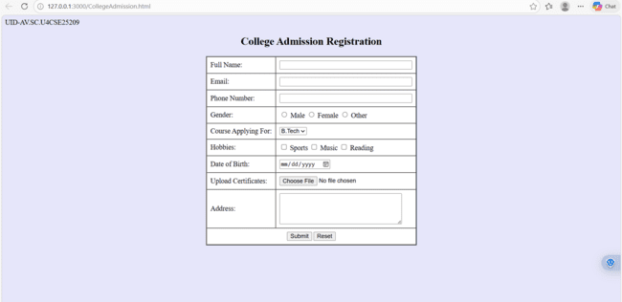
Explanation :
<DOCTYPE html> : the <!DOCTYPE html> element tells the web browser that this an HTML document
or this is the latest version of HTML
<html> : the <html> element is the root element of an HTML web page
<head> : the <head> element will contain meta data about the HTML web page
<title> : the <title> element specifies a title for the HTML Page
<body> : the <body> element contains all visible content all visible content like text , image , links ,
tables , etc
<h> : we used <h> element for heading
<p> : we used <p> element for the paragraph
<table>: the element <table> is used to create a table
<tr>: the element <tr> creates a new row in the table
<th>: the element <th> create a new heading inside the table
<td>: the element <td> fill the columns in the row
<label>:we used <label> element for linking the input to specific id name and we use for attribute for it
<input>:we use <input> element for the input elements in the forms
<select>:we use <select> element for creation of drop box
<option>:we use <option> element for creating the options in the drop box
And we use style attribute for styling and designing the webpage and type for selecting the type of input that is going to In it and for and id tag is used to link the input to label.

4.B)Aim: Two forms displayed side by side using iframes .one is login and another registration
Program :
Main code with Iframes:
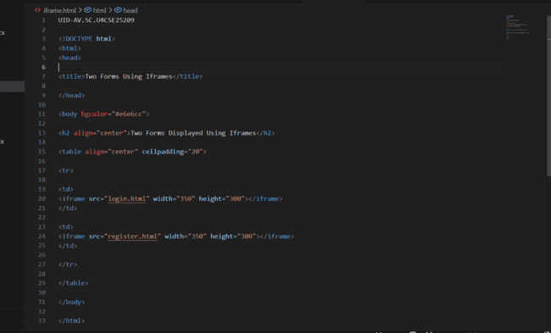

Login.html:
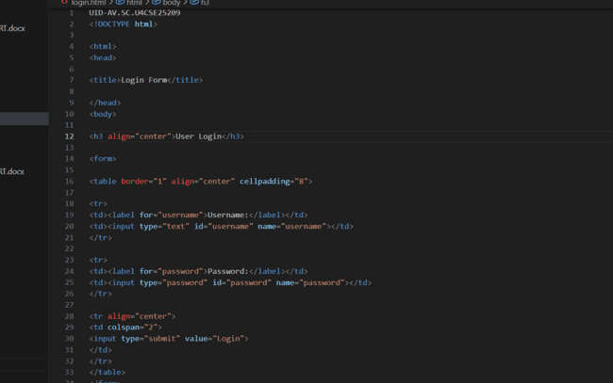
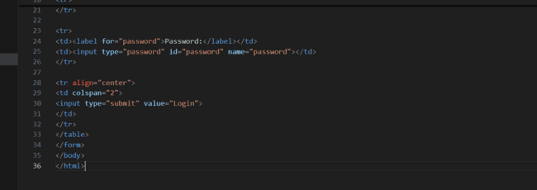
Register.html:
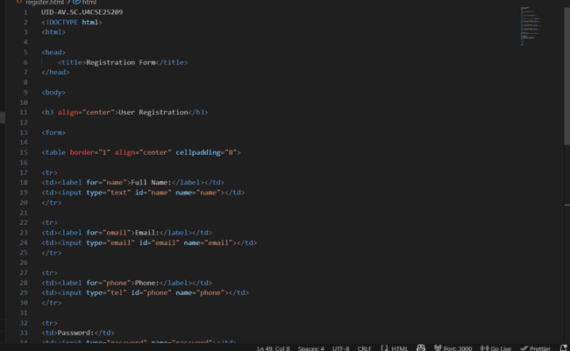
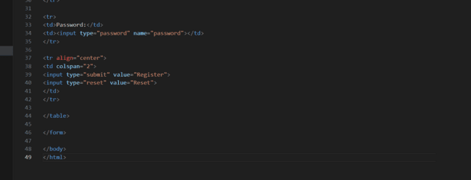

Output :
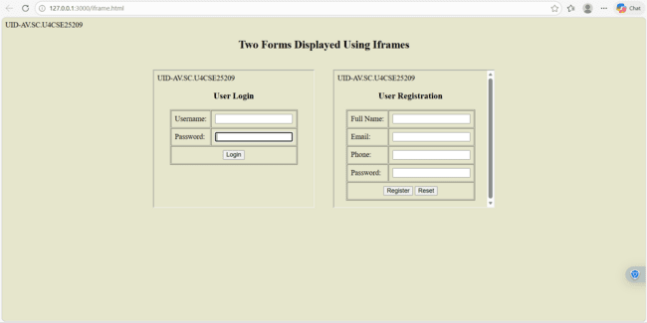

Explanation :
<DOCTYPE html> : the <!DOCTYPE html> element tells the web browser that this an HTML document
or this is the latest version of HTML
<html> : the <html> element is the root element of an HTML web page
<head> : the <head> element will contain meta data about the HTML web page
<title> : the <title> element specifies a title for the HTML Page
<body> : the <body> element contains all visible content all visible content like text , image , links ,
tables , etc
<h> : we used <h> element for heading
<p> : we used <p> element for the paragraph
<table>: the element <table> is used to create a table
<tr>: the element <tr> creates a new row in the table
<th>: the element <th> create a new heading inside the table
<td>: the element <td> fill the columns in the row
<label>:we used <label> element for linking the input to specific id name and we use for attribute for it
<input>:we use <input> element for the input elements in the forms
<select>:we use <select> element for creation of drop box
<option>:we use <option> element for creating the options in the drop box
<iframes>:we use <iframes> element for adding anoter html file to main html file
And we use style attribute for styling and designing the webpage and type for selecting the type of input that is going to In it and for and id tag is used to link the input to label and use the iframe for use the table and add two iframes in two boxes

Week-5:
5.A)Aim: creating a card layout using <div> tag consider three cards and a button using html and css
Program :
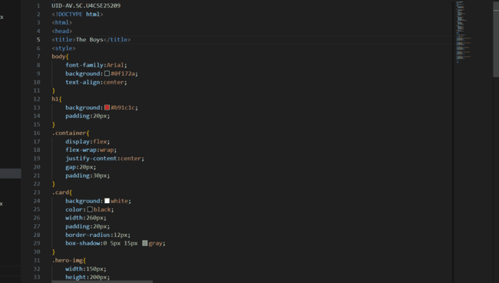

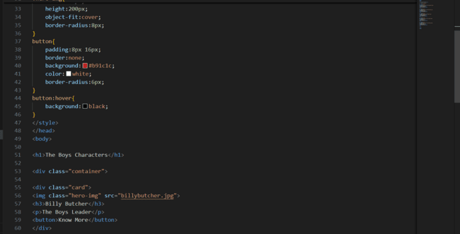
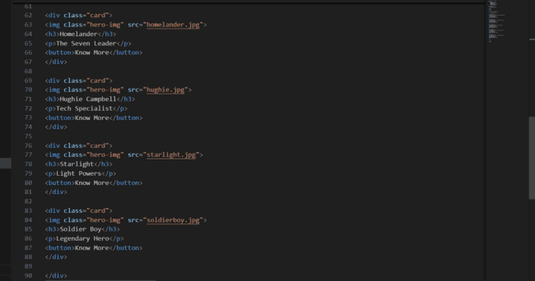

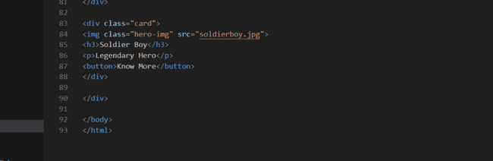
Output :
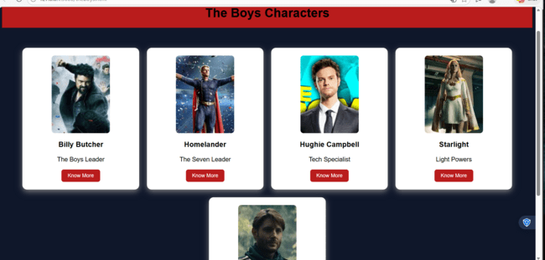

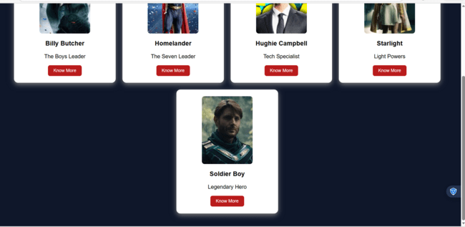
Explanation :
<DOCTYPE html> : the <!DOCTYPE html> element tells the web browser that this an HTML document
or this is the latest version of HTML
<html> : the <html> element is the root element of an HTML web page
<head> : the <head> element will contain meta data about the HTML web page
<title> : the <title> element specifies a title for the HTML Page
<body> : the <body> element contains all visible content all visible content like text , image , links ,
tables , etc
<h> : we used <h> element for heading
<p> : we used <p> element for the paragraph
<div>:we use <div> element for encapsulating the the divisions and easy to modify and
<button>: we use <button> element for button
<img>: we use <img> tag for displaying the image
And we internal css for the html page and use element and class selector to apply the css to the div elements and src attribute for image path ,by using the class and internal css we created this webpage

5.B)Aim: Navigation using iframe (mini website) upon clicking each buttons the details about that
button should be display on the same page
program:
vicecity.html:(main)
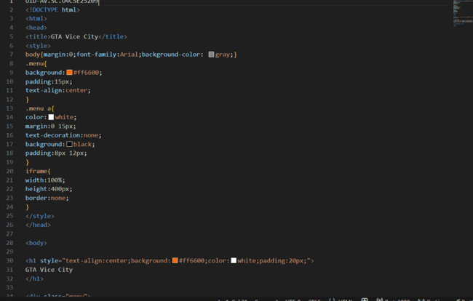

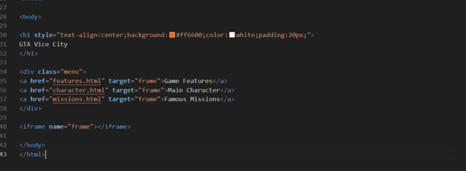

FEATURE.html:
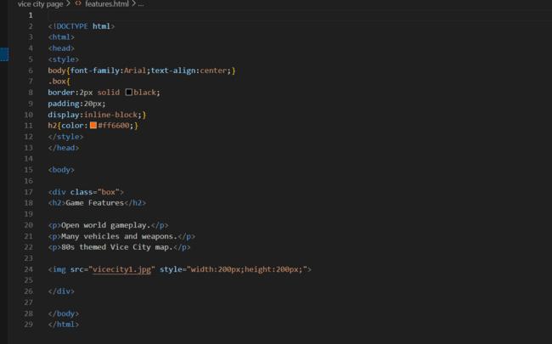
CHARACTER.html:
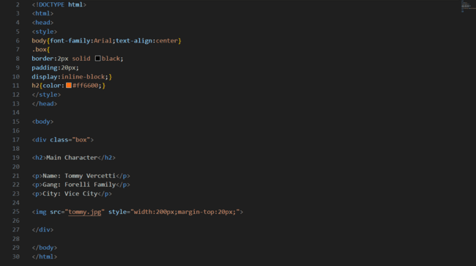
MISSIONS.html:
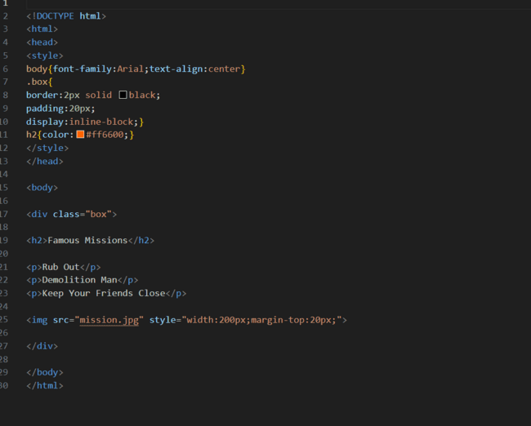

OUTPUT:
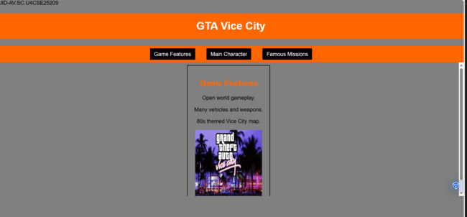

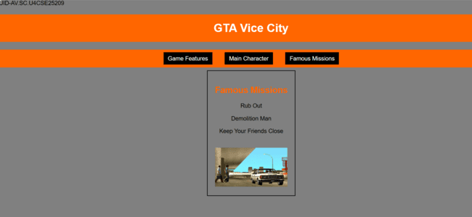
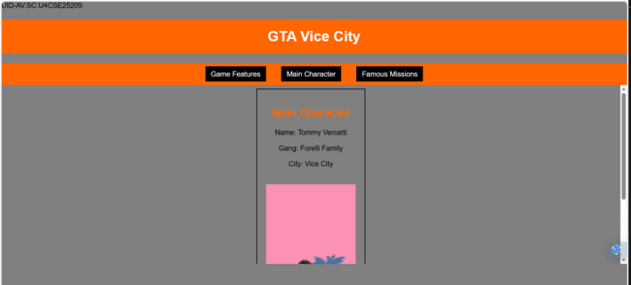

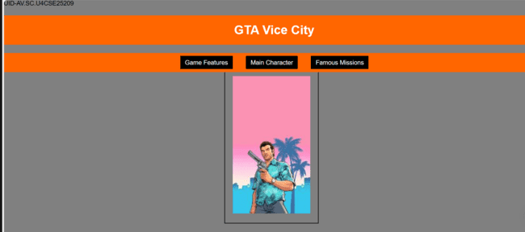

Explanation :
<DOCTYPE html> : the <!DOCTYPE html> element tells the web browser that this an HTML document
or this is the latest version of HTML
<html> : the <html> element is the root element of an HTML web page
<head> : the <head> element will contain meta data about the HTML web page
<title> : the <title> element specifies a title for the HTML Page
<body> : the <body> element contains all visible content all visible content like text , image , links ,
tables , etc
<h> : we used <h> element for heading
<p> : we used <p> element for the paragraph
<div>:we use <div> element for encapsulating the the divisions and easy to modify and
<button>: we use <button> element for button
<img>: we use <img> tag for displaying the image
And we internal css for the html page and use element and class selector to apply the css to the div elements and src attribute for image path ,by using the class and internal css we created this webpage and href attribute is used to link the html pages to the main webpage and use target attribute to link the anchor element to href attribute . and the three webpages are linked to main webpage .and inline attribute for the boder to wrap around it .

5.c)Aim: Design amrita login page by showcampus on home page.upon clicking on each campus
the details about each campus should be display on the same page use html and css to
design a stylish webpage
program:
Main file:
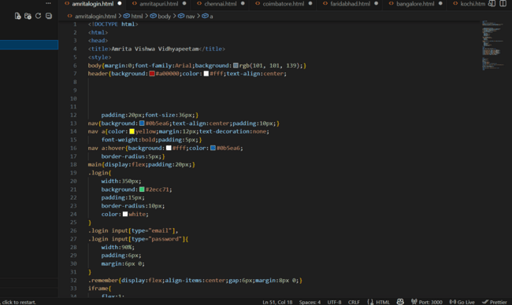
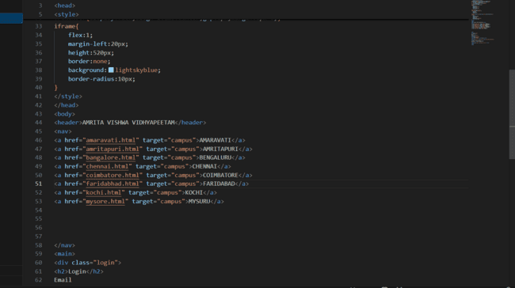
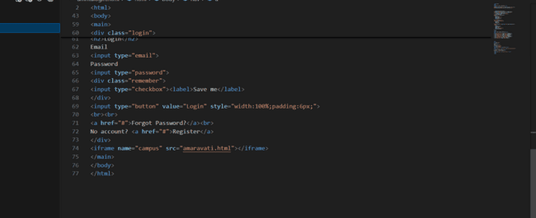
Amaravathi:
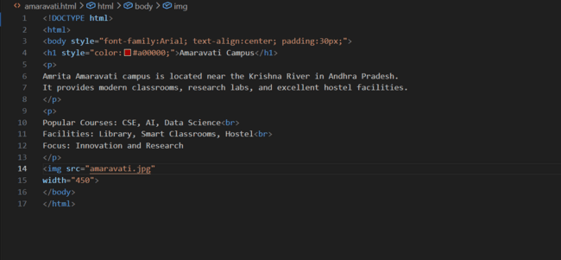
Bangalore:
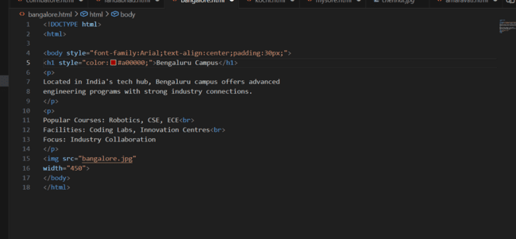
Amritapuri:
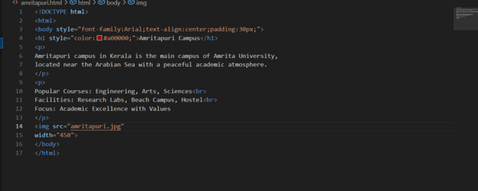
Chennai:
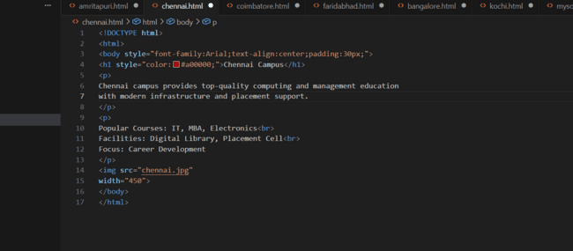
Coimbatore:
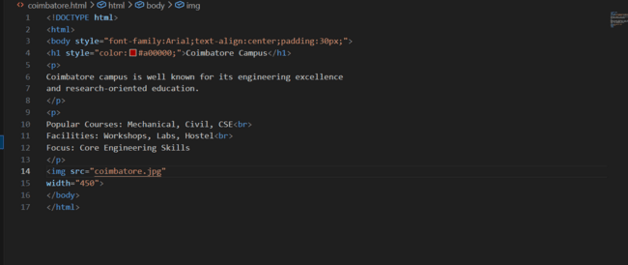
Faridabhad:
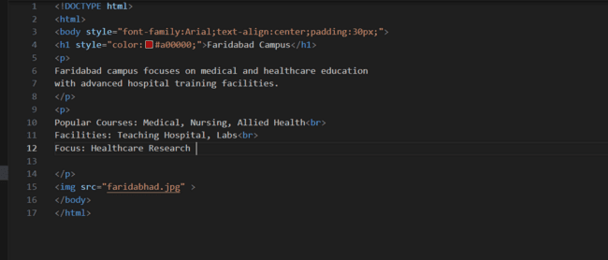
Kochi:
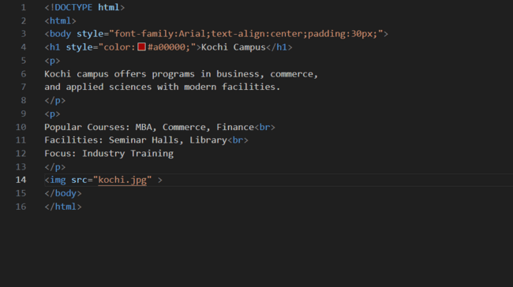
Mysore:
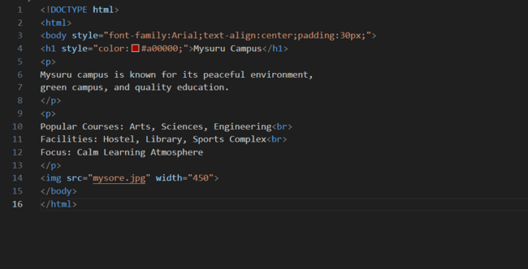
Output:
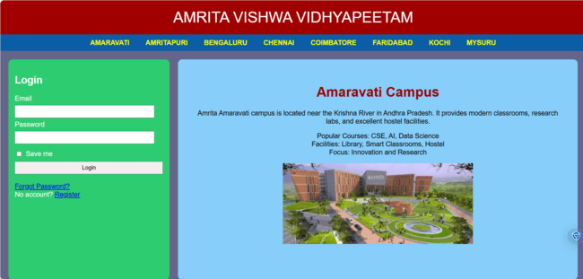
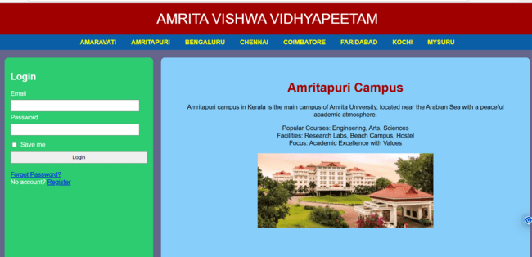
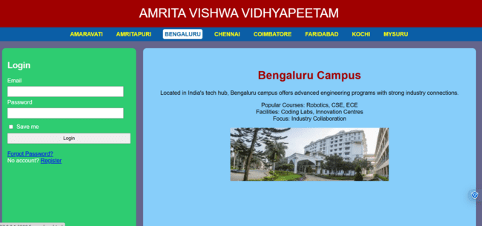
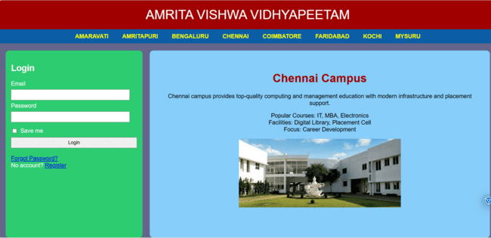
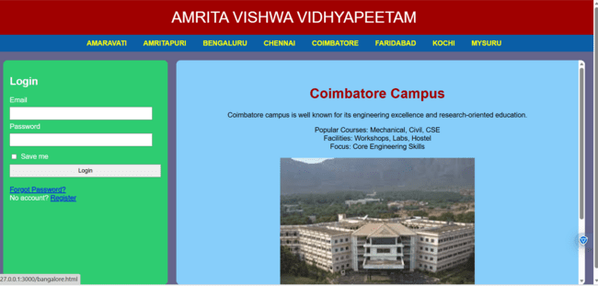
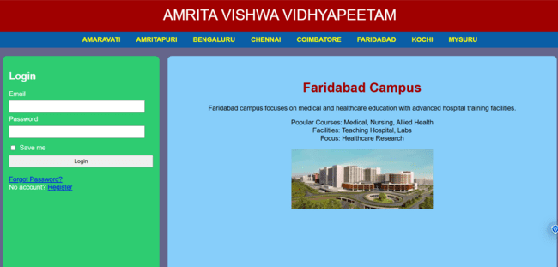
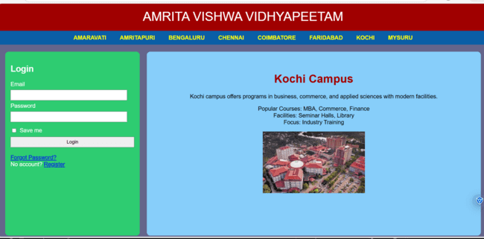
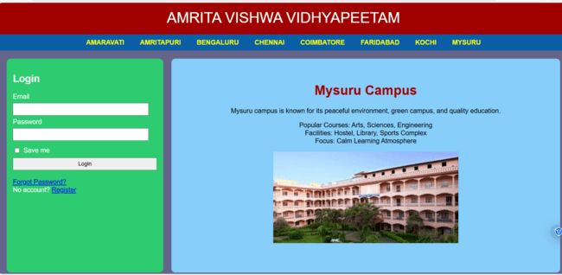
Explanation :
<DOCTYPE html> : the <!DOCTYPE html> element tells the web browser that this an HTML document
or this is the latest version of HTML
<html> : the <html> element is the root element of an HTML web page
<head> : the <head> element will contain meta data about the HTML web page
<title> : the <title> element specifies a title for the HTML Page
<body> : the <body> element contains all visible content all visible content like text , image , links ,
tables , etc
<h> : we used <h> element for heading
<p> : we used <p> element for the paragraph
<div>:we use <div> element for encapsulating the the divisions and easy to modify and
<button>: we use <button> element for button
<img>: we use <img> tag for displaying the image
We used different types of input attributes for different inputs
And we internal css for the html page and use element and class selector to apply the css to the div elements and src attribute for image path ,by using the class and internal css we created this webpage and href attribute is used to link the html pages to the main webpage and use target attribute to link the anchor element to href attribute . and the three webpages are linked to main webpage .and inline attribute for the boder to

WEEK-6

6.A. Aim: Design a responsive e-commerce application using the grid layout. This application should contain different categories of products such as electronics, clothing, home-appliances, books.
Code:-
<!DOCTYPE html>
UID-CSE25209
<html>
<head>
<title>Gadget Hub</title>
<style>
body {
font-family: Arial, sans-serif;
margin: 0;
padding: 0;
background-color: #f4f4f4;
}
.container {
display: grid;
grid-template-rows: auto auto 1fr auto;
grid-template-columns: 200px 1fr;
grid-template-areas:
"header header"
"sale sale"
"sidebar main"
"footer footer";
gap: 10px;
padding: 10px;
}
.header {
grid-area: header;
background-color: #4CAF50;
padding: 10px;
text-align: center;
color: white;
}
.sale {
grid-area: sale;
background-color: #2196F3;
padding: 10px;
text-align: center;
color: white;
}
.sidebar {
grid-area: sidebar;
background-color: #FFEB3B;
padding: 10px;
}
.main {
grid-area: main;
background-color: white;
padding: 10px;
display: grid;
grid-template-columns: repeat(2, 1fr);
gap: 10px;
}
.footer {
grid-area: footer;
background-color: #FFC107;
padding: 10px;
text-align: center;
}
.product {
background-color: #e8f5e8;
padding: 10px;
border-radius: 5px;
text-align: center;
}
.product-image {
width: 200px;
height: 200px;
}
.button {
background-color: #FF5722;
color: white;
border: none;
padding: 10px 20px;
border-radius: 5px;
}
.button:hover {
background-color: #E64A19;
}
</style>
</head>
<body>
<div class="container">
<div class="header">
<h1>GADGET HUB</h1>
</div>
<div class="sale">
<p>Special Sale!</p>
</div>
<div class="sidebar">
<h2>Categories</h2>
<ul>
<li>Laptops</li>
<li>Smartphones</li>
<li>Headphones</li>
<li>Smart Watches</li>
</ul>
</div>
<div class="main">
<div class="product">
<img class="product-image" src="game.webp" alt="Gaming Laptop">
<h3>Gaming Laptop</h3>
<p>Price: $999.99</p>
<button class="button">Add to Cart</button>
</div>
<div class="product">
<img class="product-image" src="phone.webp" alt="Smartphone">
<h3>Flagship Smartphone</h3>
<p>Price: $799.99</p>
<button class="button">Add to Cart</button>
</div>
<div class="product">
<img class="product-image" src="wireless.webp" alt="Headphones">
<h3>Wireless Headphones</h3>
<p>Price: $149.99</p>
<button class="button">Add to Cart</button>
</div>
<div class="product">
<img class="product-image" src="watch.webp" alt="Smart Watch">
<h3>Smart Watch</h3>
<p>Price: $199.99</p>
<button class="button">Add to Cart</button>
</div>
</div>
<div class="footer">
<p>&copy; GADGET HUB Website. All rights reserved.</p>
</div>
</div>
</body>
</html>

Output:-
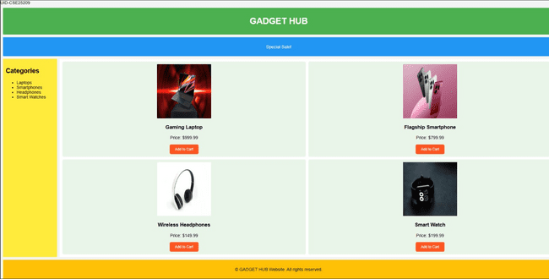

Explanation of the tags:
- display: grid: Enables CSS Grid layout system
- grid-template-areas: Defines 5 regions (header/sale/sidebar/main/footer)
- grid-area: header: Assigns element to header grid area
- grid-template-columns: 200px 1fr: Fixed 200px sidebar + flexible main
- gap: 10px: Spacing between all grid items
- padding: 10px: Inner spacing for all sections
- background-color: #4CAF50: Green header background
- text-align: center: Centers content in all sections
- repeat(2, 1fr): Creates 2-column product grid in main
- border-radius: 5px: Rounded corners on products/buttons
- .product-image { width: 200px; height: 200px }: Fixed-size product images
- background-color: #FF5722: Orange Add to Cart buttons
- :hover: Button darkens on mouseover (#E64A19)
- border: none: Removes button borders
- 1fr: Flexible units fill available space

6.B. Aim: Design a responsive e-commerce application using the grid layout. This application should contain different categories of products such as electronics, clothing, home-appliances, books. Based on the category we select corresponding products should be displayed on the sidebar.
Code:-

Main.html
<!DOCTYPE html>
<html>
<head>
<title>GADGET HUB</title>
<style>
body {
margin: 0;
font-family: Arial;
color: #333;
background: linear-gradient(135deg, #f5f7fa 0%, #c3cfe2 100%);
}
.container {
display: grid;
grid-template:
"header header" auto
"sale sale" auto
"sidebar main" 1fr
"footer footer" auto / 220px 1fr;
gap: 15px;
padding: 15px;
}
.header, .sale, .sidebar, .main, .footer {
background: rgba(255,255,255,.95);
border-radius: 12px;
padding: 15px;
box-shadow: 0 4px 20px rgba(0,0,0,0.1);
}
.header {
grid-area: header;
text-align: center;
font-size: 28px;
letter-spacing: 3px;
background: linear-gradient(45deg, #4CAF50, #45a049);
color: white;
}
.sale {
grid-area: sale;
overflow: hidden;
white-space: nowrap;
height: 40px;
position: relative;
background: linear-gradient(45deg, #2196F3, #21CBF3);
color: white;
font-weight: bold;
}
.sale p {
position: absolute;
font-size: 20px;
animation: move 10s linear infinite;
}
@keyframes move {
from { left: -100%; }
to { left: 100%; }
}
.sidebar {
grid-area: sidebar;
background: linear-gradient(135deg, #FFEB3B, #FF9800);
}
.sidebar ul { list-style: none; padding: 0; }
.sidebar li { margin: 15px 0; }
.sidebar a {
color: #333;
text-decoration: none;
font-size: 18px;
transition: .3s;
display: block;
}
.sidebar a:hover {
color: #2196F3;
padding-left: 8px;
background: rgba(255,255,255,0.5);
border-radius: 6px;
}
.main {
grid-area: main;
background: white;
}
iframe {
width: 100%;
height: 520px;
border: 0;
border-radius: 10px;
box-shadow: 0 4px 15px rgba(0,0,0,0.1);
}
.footer {
grid-area: footer;
text-align: center;
font-size: 14px;
background: linear-gradient(45deg, #FFC107, #FF9800);
color: #333;
}
</style>
</head>
<body>
<div class="container">
<div class="header">GADGET HUB</div>
<div class="sale">
<p>🔥 SPECIAL SALE – UP TO 50% OFF ON GADGETS 🔥</p>
</div>
<div class="sidebar">
<h2>Categories</h2>
<ul>
<li><a href="laptops.html" target="contentFrame">LAPTOPS</a></li>
<li><a href="smartphones.html" target="contentFrame">SMARTPHONES</a></li>
<li><a href="headphones.html" target="contentFrame">HEADPHONES</a></li>
<li><a href="smartwatches.html" target="contentFrame">SMART WATCHES</a></li>
</ul>
</div>
<div class="main">
<iframe name="contentFrame"></iframe>
</div>
<div class="footer">© GADGET HUB Website</div>
</div>
</body>
</html>

laptops.html
<!DOCTYPE html>
<html>
<head>
<title>Laptops</title>
<style>
body {
font-family: Arial, sans-serif;
margin: 0;
padding: 20px;
background: linear-gradient(135deg, #f5f7fa 0%, #c3cfe2 100%);
}
.container {
display: grid;
grid-template-columns: 1fr 1fr;
gap: 20px;
}
.card {
background: white;
padding: 20px;
border-radius: 15px;
box-shadow: 0 8px 25px rgba(0,0,0,0.1);
text-align: center;
}
.card-img {
width: 200px;
height: 200px;
border-radius: 12px;
margin-bottom: 15px;
}
.price {
font-size: 20px;
color: #4CAF50;
font-weight: bold;
}
</style>
</head>
<body>
<div class="container">
<div class="card">
<img class="card-img" src="game.webp" alt="Gaming Laptop">
<h2>GAMING PRO</h2>
<p>RTX 4080 gaming laptop</p>
<p class="price">$999.99</p>
</div>
<div class="card">
<img class="card-img" src="ultrabook.webp" alt="Ultrabook">
<h2>ULTRABOOK</h2>
<p>Lightweight productivity laptop</p>
<p class="price">$799.99</p>
</div>
<div class="card">
<img class="card-img" src="creator.webp" alt="Creator Laptop">
<h2>CREATOR STUDIO</h2>
<p>4K video editing laptop</p>
<p class="price">$1299.99</p>
</div>
<div class="card">
<img class="card-img" src="business.webp" alt="Business Laptop">
<h2>BUSINESS ELITE</h2>
<p>Enterprise grade laptop</p>
<p class="price">$899.99</p>
</div>
</div>
</body>
</html>

smartphones.html
<!DOCTYPE html>
<html>
<head>
<title>Smartphones</title>
<style>
body {
font-family: Arial, sans-serif;
margin: 0;
padding: 20px;
background: linear-gradient(135deg, #f5f7fa 0%, #c3cfe2 100%);
}
.container {
display: grid;
grid-template-columns: 1fr 1fr;
gap: 20px;
}
.card {
background: white;
padding: 20px;
border-radius: 15px;
box-shadow: 0 8px 25px rgba(0,0,0,0.1);
text-align: center;
}
.card-img {
width: 200px;
height: 200px;
border-radius: 12px;
margin-bottom: 15px;
}
.price {
font-size: 20px;
color: #4CAF50;
font-weight: bold;
}
</style>
</head>
<body>
<div class="container">
<div class="card">
<img class="card-img" src="ultra.webp" alt="Flagship Phone">
<h2>ULTRA PRO</h2>
<p>Latest flagship smartphone</p>
<p class="price">$799.99</p>
</div>
<div class="card">
<img class="card-img" src="phone.webp" alt="Midrange Phone">
<h2>MIDRANGE X</h2>
<p>Best value smartphone</p>
<p class="price">$499.99</p>
</div>
<div class="card">
<img class="card-img" src="gaming.webp" alt="Gaming Phone">
<h2>GAMER PHONE</h2>
<p>120Hz gaming smartphone</p>
<p class="price">$649.99</p>
</div>
<div class="card">
<img class="card-img" src="fold.webp" alt="Foldable Phone">
<h2>FOLD PRO</h2>
<p>Foldable display smartphone</p>
<p class="price">$999.99</p>
</div>
</div>
</body>
</html>

smartwatches.html

<!DOCTYPE html>
<html>
<head>
<title>Smart Watches</title>
<style>
body {
font-family: Arial, sans-serif;
margin: 0;
padding: 20px;
background: linear-gradient(135deg, #f5f7fa 0%, #c3cfe2 100%);
}
.container {
display: grid;
grid-template-columns: 1fr 1fr;
gap: 20px;
}
.card {
background: white;
padding: 20px;
border-radius: 15px;
box-shadow: 0 8px 25px rgba(0,0,0,0.1);
text-align: center;
}
.card-img {
width: 200px;
height: 200px;
border-radius: 12px;
margin-bottom: 15px;
}
.price {
font-size: 20px;
color: #4CAF50;
font-weight: bold;
}
</style>
</head>
<body>
<div class="container">
<div class="card">
<img class="card-img" src="s9.webp" alt="Premium Smartwatch">
<h2>PREMIUM S9</h2>
<p>Advanced health tracking watch</p>
<p class="price">$199.99</p>
</div>
<div class="card">
<img class="card-img" src="fit.webp" alt="Fitness Tracker">
<h2>FIT TRACKER</h2>
<p>24/7 fitness monitoring</p>
<p class="price">$129.99</p>
</div>
<div class="card">
<img class="card-img" src="sports.webp" alt="Sports Watch">
<h2>SPORTS PRO</h2>
<p>GPS running and cycling watch</p>
<p class="price">$249.99</p>
</div>
<div class="card">
<img class="card-img" src="watch.webp" alt="Classic Smartwatch">
<h2>CLASSIC SERIES</h2>
<p>Traditional smartwatch design</p>
<p class="price">$179.99</p>
</div>
</div>
</body>
</html>

headphones.html

<!DOCTYPE html>
<html>
<head>
<title>Headphones</title>
<style>
body {
font-family: Arial, sans-serif;
margin: 0;
padding: 20px;
background: linear-gradient(135deg, #f5f7fa 0%, #c3cfe2 100%);
}
.container {
display: grid;
grid-template-columns: 1fr 1fr;
gap: 20px;
}
.card {
background: white;
padding: 20px;
border-radius: 15px;
box-shadow: 0 8px 25px rgba(0,0,0,0.1);
text-align: center;
}
.card-img {
width: 200px;
height: 200px;
border-radius: 12px;
margin-bottom: 15px;
}
.price {
font-size: 20px;
color: #4CAF50;
font-weight: bold;
}
</style>
</head>
<body>
<div class="container">
<div class="card">
<img class="card-img" src="premium.webp" alt="Wireless Over-ear">
<h2>PREMIUM OVER-EAR</h2>
<p>ANC wireless headphones</p>
<p class="price">$149.99</p>
</div>
<div class="card">
<img class="card-img" src="wireless.webp" alt="True Wireless">
<h2>TRUE WIRELESS</h2>
<p>Compact earbuds with case</p>
<p class="price">$79.99</p>
</div>
<div class="card">
<img class="card-img" src="gami.webp" alt="Gaming Headset">
<h2>GAMING HEADSET</h2>
<p>7.1 surround sound headset</p>
<p class="price">$99.99</p>
</div>
<div class="card">
<img class="card-img" src="studio.webp" alt="Studio Headphones">
<h2>STUDIO PRO</h2>
<p>Professional monitoring headphones</p>
<p class="price">$199.99</p>
</div>
</div>
</body>
</html>

Output:
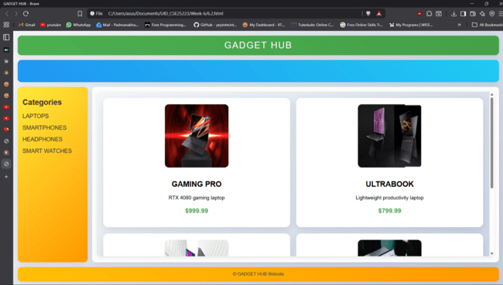
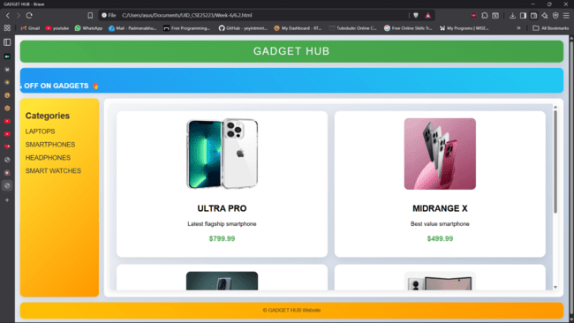
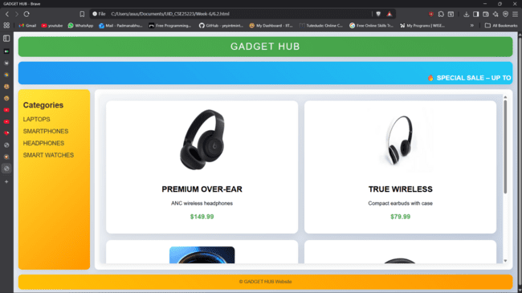
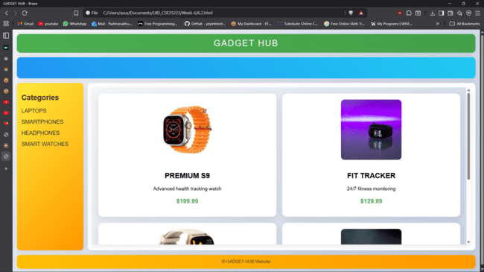

Explanation of the tags:
- target="contentFrame": Loads linked pages inside specific iframe by name
- name="contentFrame": Names iframe so menu links can target it
- grid-template: CSS Grid shorthand for rows, columns, and areas
- grid-area: header: Assigns element to named grid area
- linear-gradient(135deg, #f5f7fa 0%, #c3cfe2 100%): Light theme background gradient
- @keyframes move: Creates scrolling sale text animation
- animation: move 10s linear infinite: Continuous movement of sale banner text
- box-shadow: 0 4px 20px rgba(0,0,0,0.1): Adds soft shadow around sections/cards
- transition: .3s: Smooth hover effect on sidebar links
- display: block: Makes sidebar links take full line width
- border-radius: 10px: Rounds iframe corners
- grid-template-columns: 1fr 1fr: Creates 2-column product layout in sub-pages
- rgba(255,255,255,.95): Semi-transparent white section background
- font-weight: bold: Makes text thicker for emphasis
- letter-spacing: 3px: Adds spacing between header letters

WEEK-7
7.Aim: Create a Github Repository and upload all related files of lab manual.
Procedure:
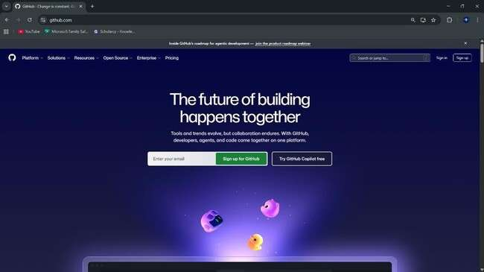
Step-1: Browse to Github and create an Account.

Step-2:Login to Github and Create a Repository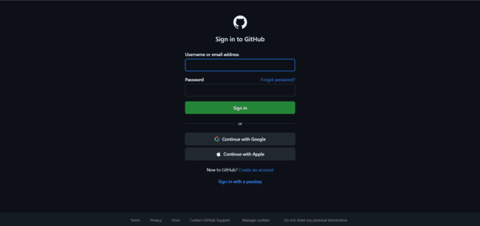

Step-3: Create a repository after login by clicking new.
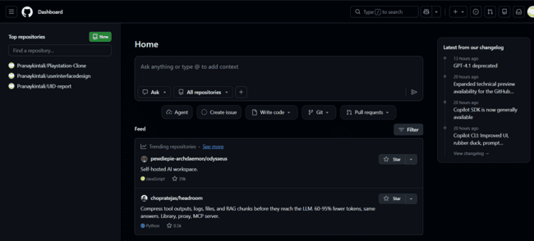
Step-4: Specify the Repository specifications
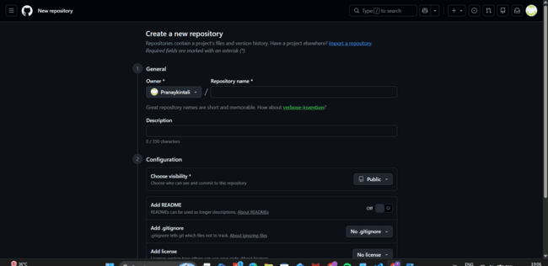
Step-5: Download Github Desktop and Launch it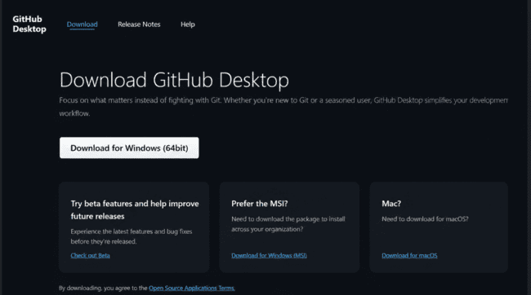

Step-6:In Github Desktop app setup a folder from your explorer.
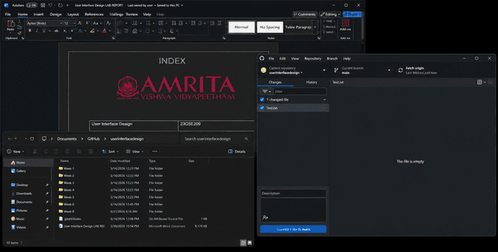

Step-7:Add all Week files to the folder linked to Github.
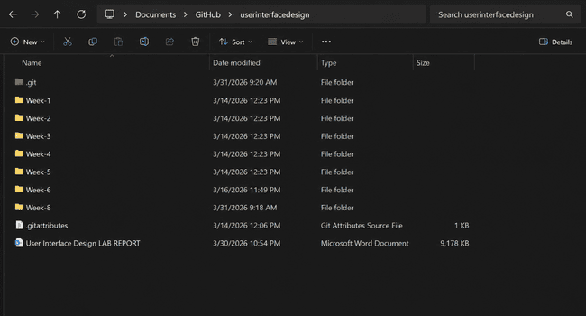

Step-8:Now click on Commit changes and Push the files in the GithubDesktop Applications.

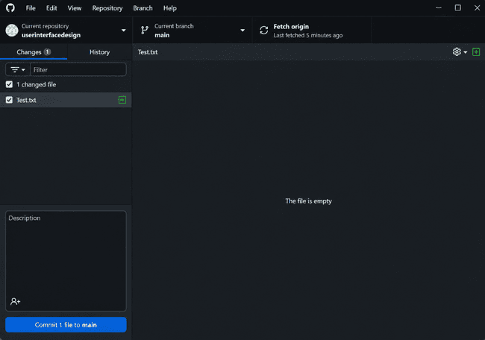
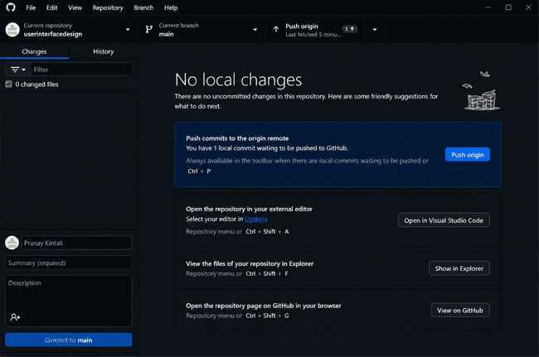
Step-9: Now go to browser and check it. All the new added files in the repository .
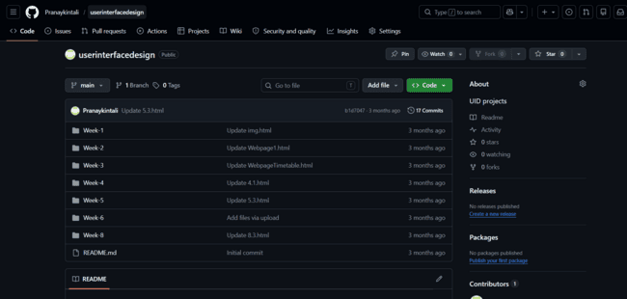

Link:https://github.com/Pranaykintali/userinterfacedesign

WEEK-8
8.A.Aim: Create a webpage that displays a square that continuously rotates 360
degree using CSS Animation.
Code:
<!DOCTYPE html>
<head>
AV.SC.U4CSE25209
<style>
div {
width: 100px;
height: 100px;
background: whitesmoke;
margin: 100px auto;
animation: mymove 5s infinite linear;
}

@keyframes mymove {
from {transform: rotate(0deg);}
to {transform: rotate(360deg);}
}
</style>
</head>

<body style="background-color: greenyellow;">
<div></div>
</body>
Output:
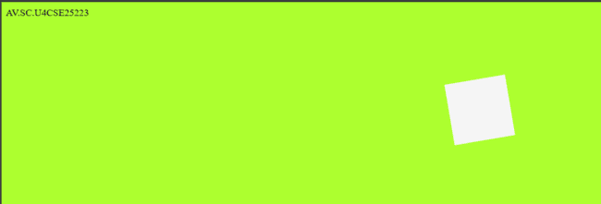
Explanation of the tags:
• animation: mymove 5s infinite linear: Runs animation for 5s, repeats forever, linear speed.
• @keyframes mymove: Defines animation steps from start to end
• transform: rotate(0deg): Rotates element 0 degrees (start position)
• transform: rotate(360deg): Rotates element full circle (end position)
• width: 100px; height: 100px: Creates square shape
• margin: 100px auto: Centers square horizontally, adds top spacing
• background: whitesmoke: Light gray square color

8.B.Aim: Create a ball that moves up and down continuously using CSS Animation.
Code:
<!DOCTYPE html>
<head>
AV.SC.U4CSE25209
<style>
div {
width: 100px;
height: 100px;
background: whitesmoke;
border-radius: 50%;
position: relative;
animation: mymove 2s infinite alternate;
}

@keyframes mymove {
from {top: 0px;}
to {top: 200px;}
}
</style>
</head>

<body style="background-color: greenyellow;">
<div></div>
</body>
Output:
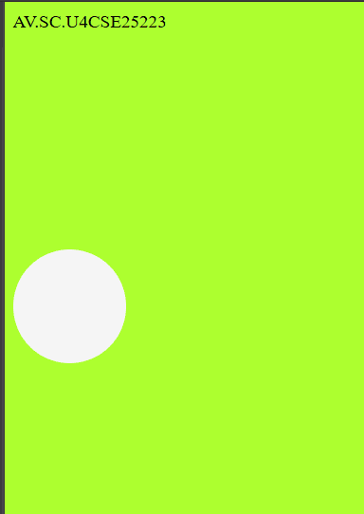

Explanation of the tags:
• border-radius: 50%: Makes square into perfect circle
• position: relative: Allows top positioning from original spot
• animation: mymove 2s infinite alternate: Bounces up/down every 2s, reverses direction
• top: 0px: Starting position at top
• top: 200px: Ending position 200px down
• @keyframes mymove: Defines bounce path from top to bottom
• width/height: Creates circular ball shape
• infinite alternate: Keeps bouncing back and forth

8.C.Aim: Create a circle that moves horizontally and rotates at the same time
using CSS Animation.
Code:
<!DOCTYPE html>
<head>
AV.SC.U4CSE25209
<style>
div {
width: 100px;
height: 100px;
background: whitesmoke;
border-radius: 50%;
position: relative;
animation: mymove 5s infinite linear;
}
@keyframes mymove {
from {
left: 0px;
transform: rotate(0deg);
}
to {
left: 200px;
transform: rotate(360deg);
}
}
</style>
</head>
<body style="background-color: greenyellow;">
<div></div>
</body>

Output:
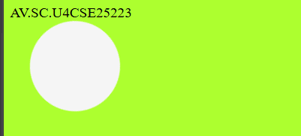

Explanation of the tags:
• border-radius: 50%: Makes square into perfect circle
• position: relative: Allows top positioning from original spot
• animation: mymove 2s infinite alternate: Bounces up/down every 2s, reverses direction
• top: 0px: Starting position at top
• top: 200px: Ending position 200px down
• @keyframes mymove: Defines bounce path from top to bottom
• width/height: Creates circular ball shape
• infinite alternate: Keeps bouncing back and forth

WEEK-9
9.Aim: Create a webpage using HTML, CSS, JS based on the give conditions:
a) Create a button for each program, based on the button, clicked the corresponding program has to be executed and should display the output.
b)The logics for each button includes finding an even or odd number, prime or not, factorial of a number, Armstrong or not.
c)Use appropriate design to display the output.
Code: <!DOCTYPE html>
AV.SC.U4CSE25209
<html>
<head>
<title>Number Checker</title>

<style>
body {
font-family: Arial;
text-align: center;
background-color: #f2f2f2;
}

.box {
width: 300px;
margin: 100px auto;
padding: 20px;
background: white;
border-radius: 10px;
box-shadow: 0 0 10px gray;
}

input {
width: 80%;
height: 30px;
margin: 10px;
}

button {
margin: 5px;
padding: 10px;
cursor: pointer;
}

#output {
margin-top: 15px;
font-weight: bold;
}
</style>
</head>

<body>

<div class="box">
<h2>Number Operations</h2>

<input type="number" id="num" placeholder="Enter number">

<br>

<button onclick="checkEvenOdd()">Even / Odd</button>
<button onclick="checkPrime()">Prime</button>
<button onclick="findFactorial()">Factorial</button>
<button onclick="checkArmstrong()">Armstrong</button>

<div id="output"></div>
</div>

<script>

function getNumber() {
return parseInt(document.getElementById("num").value);
}

// Even / Odd
function checkEvenOdd() {
let n = getNumber();
if (n % 2 === 0)
document.getElementById("output").innerText = n + " is EVEN";
else
document.getElementById("output").innerText = n + " is ODD";
}

// Prime
function checkPrime() {
let n = getNumber();
let isPrime = true;

if (n <= 1) isPrime = false;

for (let i = 2; i <= Math.sqrt(n); i++) {
if (n % i === 0) {
isPrime = false;
break;
}
}

document.getElementById("output").innerText =
isPrime ? n + " is PRIME" : n + " is NOT PRIME";
}

// Factorial
function findFactorial() {
let n = getNumber();
let fact = 1;

if (n < 0) {
document.getElementById("output").innerText = "Factorial not possible";
return;
}

for (let i = 1; i <= n; i++) {
fact *= i;
}

document.getElementById("output").innerText =
"Factorial of " + n + " = " + fact;
}

// Armstrong
function checkArmstrong() {
let n = getNumber();
let sum = 0;
let temp = n;
let digits = n.toString().length;

while (temp > 0) {
let rem = temp % 10;
sum += Math.pow(rem, digits);
temp = Math.floor(temp / 10);
}

document.getElementById("output").innerText =
(sum === n) ? n + " is ARMSTRONG" : n + " is NOT ARMSTRONG";
}

</script>

</body>
</html>
Output:
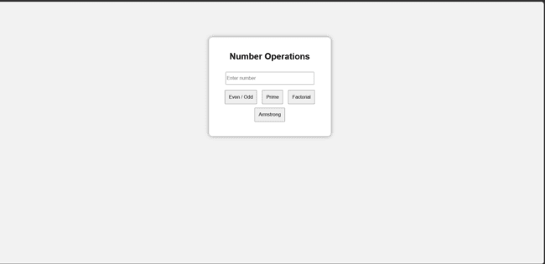
Explanation of the tags:
- <html> – Top-level container for the entire HTML page.
- <head> – Holds metadata, title, styles, and scripts.
- <title> – Sets the page title shown in the browser tab.
- <body> – Contains all visible content of the page.
- <div class="container"> – Groups the main UI into a styled card.
- <h2> – Second-level heading for “Logic Programs”.
- <input type="number"> – Text box that accepts only numeric input.
- id="numInput" – Unique name used in JavaScript to access the input.
- onclick="checkEvenOdd()" – Runs the checkEvenOdd function when the button is clicked.

WEEK-10
- Aim:
- 10(A): write JavaScript conditional statement to find the sign of product of three numbers using functions. Display an alert box with specified sign.
- 10(B): write a java script conditional statements to sort 3 numbers using functions display an alert box to show the result.
- 10(C): write a java script conditional statement to find largest of find largest of five numbers using function and onclick event. display an alert box to show the result
- 10(D): write a java script for loop that will iterate from 0 to 15. For each iteration, it will
- check if the current number odd or even, and display a message on screen
- 10(E) write a java script program to read 6 subjects marks from the student then computes the average marks of students, this average is used to determine the corresponding grade

- Code:
- <!DOCTYPE html>
- <html>
- <head>
- <title>JavaScript Lab Programs</title>

- <style>
- *{
- margin:0;
- padding:0;
- box-sizing:border-box;
- font-family:Arial, sans-serif;
- }

- body{
- background:#f2f2f2;
- display:flex;
- justify-content:center;
- align-items:center;
- height:100vh;
- }

- .container{
- width:950px;
- background:white;
- display:flex;
- border-radius:8px;
- overflow:hidden;
- box-shadow:0 0 15px rgba(0,0,0,0.2);
- }

- .left{
- width:45%;
- padding:30px;
- }

- .right{
- width:55%;
- padding:30px;
- border-left:1px solid #ddd;
- }

- h2{
- margin-bottom:20px;
- }

- button{
- width:100%;
- padding:15px;
- margin-bottom:18px;
- border:none;
- border-radius:6px;
- background:#4a89dc;
- color:white;
- font-size:18px;
- cursor:pointer;
- }

- button:hover{
- background:#3575cc;
- }

- #output{
- background:#eef1f5;
- height:330px;
- padding:20px;
- border-radius:6px;
- overflow:auto;
- font-size:18px;
- }
- </style>
- </head>

- <body>

- <div class="container">

- <div class="left">
- <h2>Functions</h2>

- <button onclick="signProduct()">
- Sign of Product
- </button>

- <button onclick="sortNumbers()">
- Sort Numbers
- </button>

- <button onclick="largestNumber()">
- Largest Number
- </button>

- <button onclick="oddEven()">
- Odd / Even 0-15
- </button>

- <button onclick="lolOk()">
- LOL / OK 1-100
- </button>

- </div>

- <div class="right">

- <h2>Output</h2>

- <div id="output">
- Result will appear here
- </div>

- </div>

- </div>

- <script>

- // 1. Sign of Product

- function signProduct(){

- let a = Number(prompt("Enter first number:"));
- let b = Number(prompt("Enter second number:"));
- let c = Number(prompt("Enter third number:"));

- let result="";

- if(a==0 || b==0 || c==0){
- result="The product is 0";
- }
- else if(a*b*c > 0){
- result="The sign is Positive (+)";
- }
- else{
- result="The sign is Negative (-)";
- }

- document.getElementById("output").innerHTML=result;
- }

- // 2. Sort Numbers

- function sortNumbers(){

- let a = Number(prompt("Enter first number:"));
- let b = Number(prompt("Enter second number:"));
- let c = Number(prompt("Enter third number:"));

- let arr=[a,b,c];

- arr.sort(function(x,y){
- return x-y;
- });

- document.getElementById("output").innerHTML=
- "Sorted Numbers:<br><br>" +
- arr.join(" , ");
- }

- // 3. Largest Number

- function largestNumber(){

- let a = Number(prompt("Enter number 1:"));
- let b = Number(prompt("Enter number 2:"));
- let c = Number(prompt("Enter number 3:"));
- let d = Number(prompt("Enter number 4:"));
- let e = Number(prompt("Enter number 5:"));

- let max=a;

- if(b>max) max=b;
- if(c>max) max=c;
- if(d>max) max=d;
- if(e>max) max=e;

- document.getElementById("output").innerHTML=
- "Largest Number = <b>"+max+"</b>";
- }

- // 4. Odd Even

- function oddEven(){

- let result="";

- for(let i=0;i<=15;i++){

- if(i%2==0){
- result += i + " is EVEN<br>";
- }
- else{
- result += i + " is ODD<br>";
- }
- }

- document.getElementById("output").innerHTML=result;
- }

- // 5. LOL OK

- function lolOk(){

- let result="";

- for(let i=1;i<=100;i++){

- if(i%3==0 && i%5==0){
- result += "LOL-OK<br>";
- }
- else if(i%3==0){
- result += "LOL<br>";
- }
- else if(i%5==0){
- result += "OK<br>";
- }
- else{
- result += i + "<br>";
- }
- }

- document.getElementById("output").innerHTML=result;
- }

- </script>

- </body>
- </html>

Output:

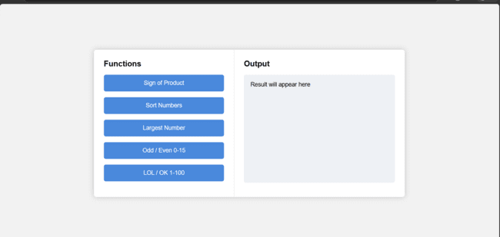
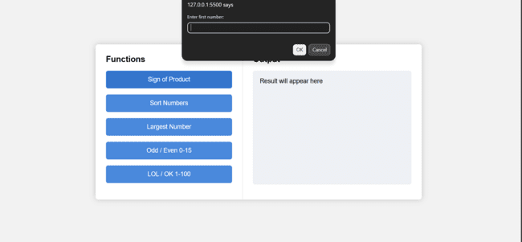
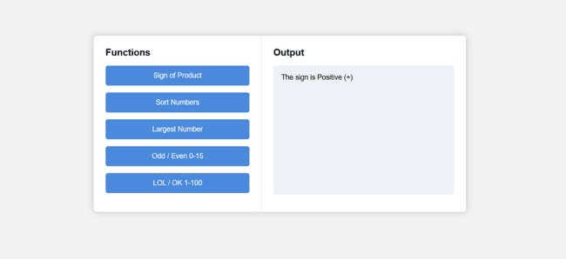

Explanation:
- <!DOCTYPE html> → Declares the document as HTML5.
- <html> → Root element containing entire webpage.
- <head> → Holds metadata like title.
- <title> → Sets the browser tab name.
- <body> → Contains all visible content.
- <h3> → Displays a heading.
- <input> → Takes user input.
- type="password" → Hides typed characters.
- id → Uniquely identifies an element.
- onkeyup → Triggers function when user types.
- <p> → Displays text/output.
- <script> → Contains JavaScript code.
- function → Defines a reusable block of code.
- document. getElementById() → Selects an HTML element using its ID.
- .value → Gets input field value.
- let → Declares a variable.
- if → Executes code if condition is true.
- else if → Checks another condition if previous is false.
- else → Runs if all conditions are false.
- . length → Returns number of characters in a string.
- match () → Checks if a pattern exists in a string.
- /[A-Z]/ → Checks for uppercase letters.
- /[0-9]/ → Checks for digits.
- /[@$!%*? &]/ → Checks for special characters.
- && → Logical AND (all conditions must be true).
- = → Assigns value to a variable.
- inner Text → Updates text inside an HTML element.

- WEEK-11
AIM:
- 1. A website requires users to enter a username. The system should display a message while typing if the username is less than 5 characters.
- 2. A registration form should validate email format before submission. If invalid, the form should not be submitted.
- 3. A system should check password strength while typing and display whether it is weak or strong.
- 4. A form should validate a mobile number when the user leaves the input field. The number must be exactly 10 digits.
- 5. Design an HTML page, such that the registration form must validate:
- Name (not empty)
- Email (valid format)
- Password (minimum 6 characters).

- CODE:

- <!DOCTYPE html>
- <html>
- <head>
- <title>Username Validation</title>
- </head>
- <body>
- <h3>Username</h3>
- <input type="text" id="username" onkeyup="checkUsername()" />
- <p id="msg"></p>

- <script>
- function checkUsername() {
- let name = document.getElementById("username").value;

- document.getElementById("msg").innerText =
- name.length < 5 ? "Minimum 5 characters required" : "";
- }
- </script>
- </body>
- </html>

OUTPUT:
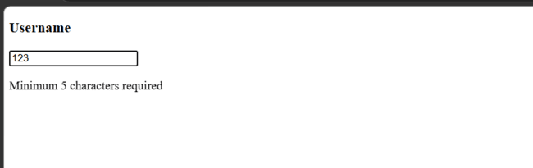
CODE:
<!DOCTYPE html>
<html>
<head>
<title>Email Validation</title>
</head>
<body>
<h3>Email</h3>

<form onsubmit="return validateEmail();">
<input type="text" id="email" />
<button type="submit">Submit</button>
</form>

<script>
function validateEmail() {
let email = document.getElementById("email").value;

let pattern = /^[^ ]+@[^ ]+\.[a-z]{2,3}$/;

if (!pattern.test(email)) {
alert("Invalid email format");
return false;
}

return true;
}
</script>
</body>
</html>
OUTPUT:
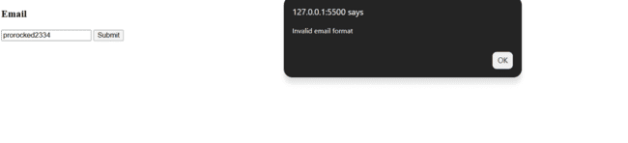
CODE:
<!DOCTYPE html>
<html>
<head>
<title>Password Strength</title>
</head>
<body>
<h3>Password</h3>

<input type="password" id="password" onkeyup="checkPassword()" />
<p id="strength"></p>

<script>
function checkPassword() {
let pass = document.getElementById("password").value;
let msg = "";

if (pass.length < 6) {
msg = "Weak (too short)";
}
else if (
pass.match(/[A-Z]/) && // uppercase
pass.match(/[0-9]/) && // number
pass.match(/[@$!%*?&]/) // special char
) {
msg = "Strong Password";
}
else {
msg = "Medium (add uppercase, number, special char)";
}

document.getElementById("strength").innerText = msg;
}
</script>
</body>
</html>
OUTPUT:
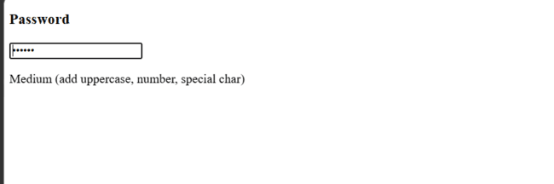
CODE:
<!DOCTYPE html>
<html>
<head>
<title>Mobile Validation</title>
</head>
<body>
<h3>Mobile Number</h3>

<input type="text" id="mobile" onblur="checkMobile()" />
<p id="msg"></p>

<script>
function checkMobile() {
let num = document.getElementById("mobile").value;

if (num.length !== 10 || isNaN(num)) {
document.getElementById("msg").innerText =
"Enter valid 10-digit number";
} else {
document.getElementById("msg").innerText = "";
}
}
</script>
</body>
</html>
OUTPUT:
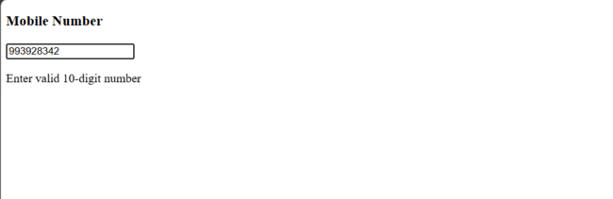
CODE:
<!DOCTYPE html>
<html>
<head>
<title>Registration Form</title>
</head>
<body>
<h3>Register</h3>

<form onsubmit="return validateForm();">
Name: <input type="text" id="name" /><br /><br />
Email: <input type="text" id="email" /><br /><br />
Password: <input type="password" id="password" /><br /><br />

<button type="submit">Submit</button>
</form>

<script>
function validateForm() {
let name = document.getElementById("name").value;
let email = document.getElementById("email").value;
let password = document.getElementById("password").value;

let pattern = /^[^ ]+@[^ ]+\.[a-z]{2,3}$/;

if (name === "") {
alert("Name required");
return false;
}

if (!pattern.test(email)) {
alert("Invalid email");
return false;
}

if (password.length < 6) {
alert("Password must be at least 6 characters");
return false;
}

return true;
}
</script>
</body>
</html>
OUTPUT:
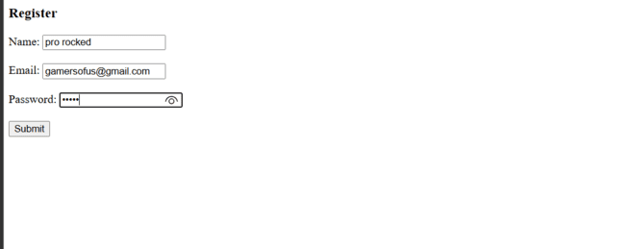

Explanation:
<!DOCTYPE html> → Declares HTML5 document type.
<html> → Root of the webpage.
<head> → Contains metadata.
<title> → Sets tab title.
<body> → Holds visible content.
<h3> → Displays heading text.
<form> → Collects user input.
on submit → Runs function before form submission.
<input> → Takes user input.
type="text" → Plain text input.
type="password" → Hides typed characters.
id → Unique identifier for element.
onkeyup → Triggers function while typing.
onblur → Triggers when input loses focus.
<p> → Displays messages.
<button> → Submits form.
<script> → Contains JavaScript code.
function → Defines reusable block of code.
document.getElementById() → Selects element using ID.
.value → Gets input value.
let → Declares variable.
if → Executes code if condition is true.
else if → Checks another condition.
else → Executes if all conditions fail.
.length → Returns number of characters.
match() → Checks pattern in string.
test() → Tests regex pattern (true/false).
/regex/ → Defines pattern for validation.
[A-Z] → Matches uppercase letters.
[0-9] → Matches digits.
[@$!%*?&] → Matches special characters.
&& → Logical AND operator.
! → Logical NOT operator.
=== → Strict equality check.
!== → Strict inequality check.
= → Assigns value.
innerText → Updates text inside element.
alert() → Displays popup message.
return false → Stops form submission.
isNaN() → Checks if value is not a number.

WEEK-12
Aim: Installation of Electron
Steps for installation of electron:
Step1: Open Google Chrome browser.
open:
Node.js Official Website
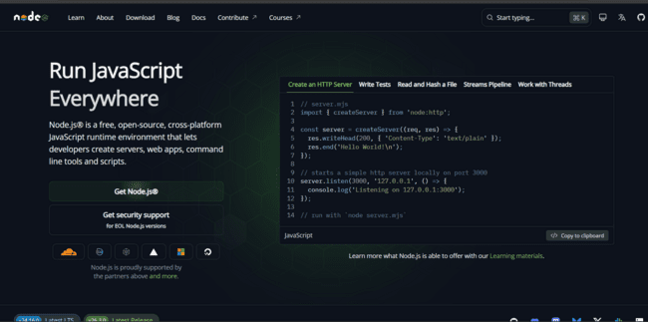

- Download the LTS version
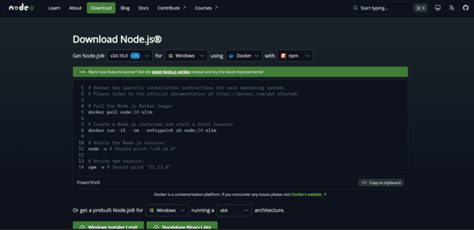
- Install it
- Keep clicking Next → Next → Install
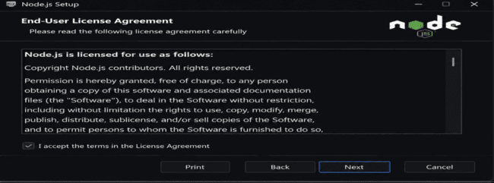

Node.js automatically installs:
- Node
- npm (Node Package Manager)

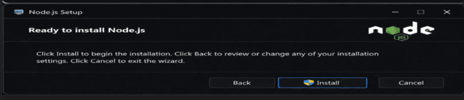
Step2:
Open VS Code.
Open terminal:
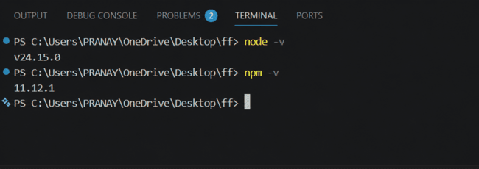

Step3:
Create New Empty Folder
- Create a new folder anywhere
Example:
ElectronApp
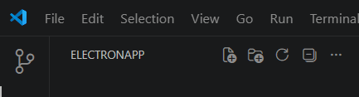
Step4 — Initialize Node Project
Run:
npm init -y
This creates:
package.json
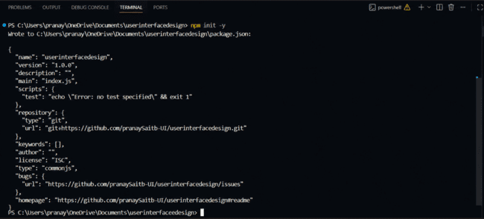

Step5 — Install Electron
Run:
npm install electron --save-dev
Wait until installation finishes.
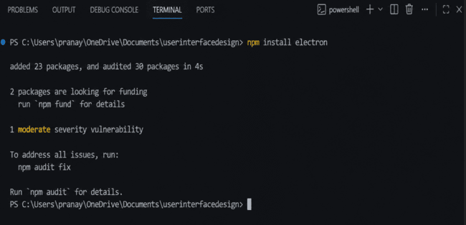
Step6 — Modify package.json
Open package.json
Add:

"main": "main.js",
Inside "scripts" add:
"start": "electron ."

Final example:
{
"name": "electronapp",
"version": "1.0.0",
"main": "main.js",
"scripts": {
"start": "electron ."
}
}
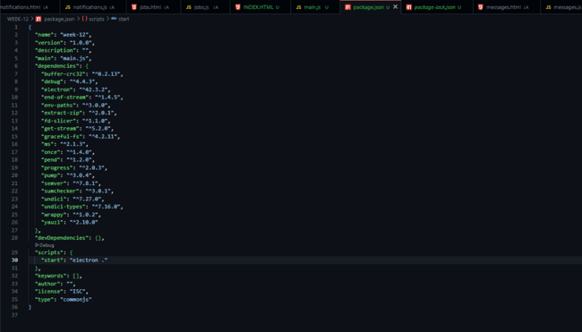

Step7 — Open Electron Official Website
Open Chrome.
Go to:
Electron.js Official Website
Navigate:
Docs → Tutorial → Building Your First App
Copy the Final Starter Code.

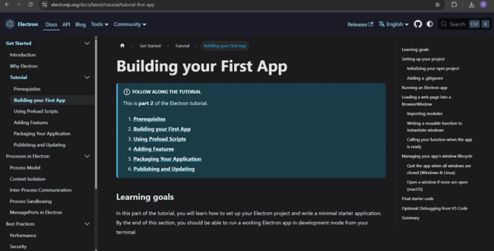

Step8 — Create Required Files
Inside your project folder create:
main.js
index.html

Step9 — Paste Electron Code in main.js
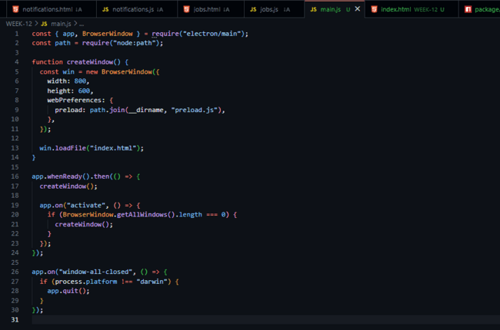
Step10 — Add HTML File
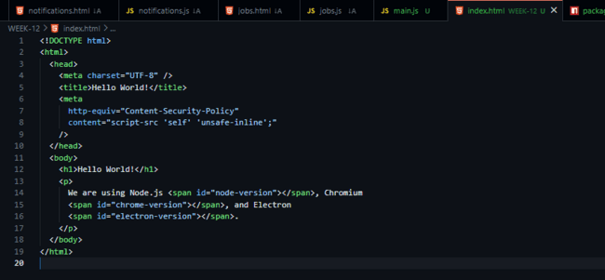
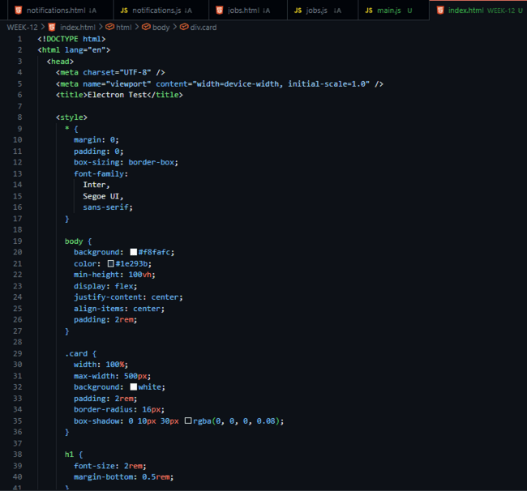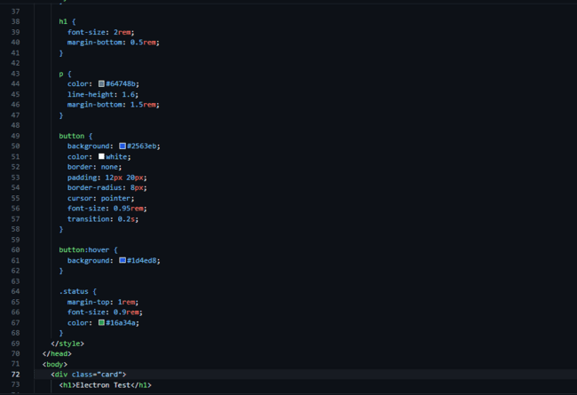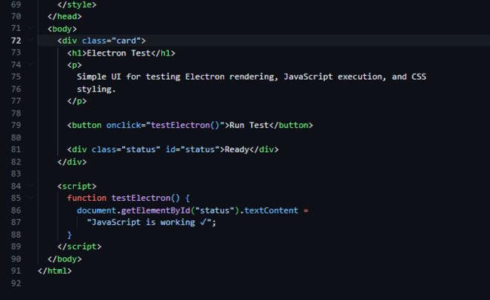

Step11 — Verify File Names
Make sure:
win.loadFile('index.html')
matches your actual HTML filename.
Step11 — Verify File Names
Make sure:
win.loadFile('index.html')
matches your actual HTML filename.
Output:
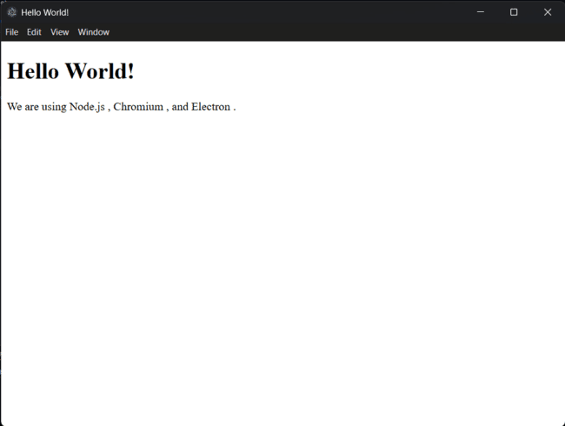
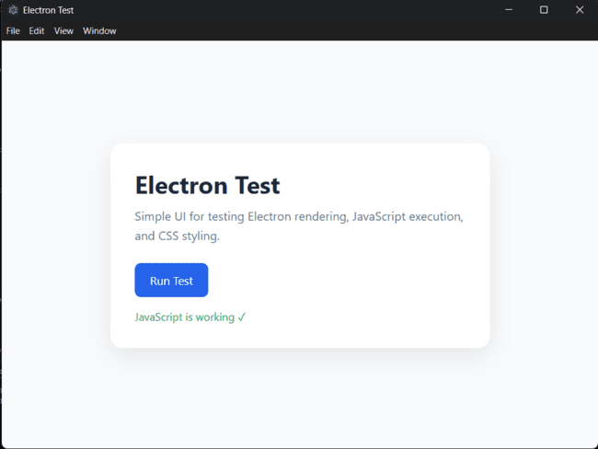
Description:

Description of Modules Used
1. Node.js
Node.js is a JavaScript runtime environment used to execute JavaScript code outside the browser. It provides the backend environment required for Electron applications. In this project, Node.js is used to initialize the project, install dependencies, and manage packages using npm.

2. npm (Node Package Manager)
npm is the default package manager for Node.js. It is used to install Electron and other required libraries into the project. Commands such as npm init -y, npm install electron --save-dev, and npm start are executed using npm.

3. Electron.js
Electron.js is an open-source framework used for building desktop applications using HTML, CSS, and JavaScript. It combines Chromium and Node.js, allowing web applications to run as desktop software on Windows, Linux, and macOS.

4. main.js
The main.js file is the main entry point of the Electron application. It creates the application window using the BrowserWindow module and controls the lifecycle of the desktop application.
Main functions of main.js:
• Creates the application window
• Loads the HTML file
• Handles application startup and closing events

5. BrowserWindow Module
BrowserWindow is an Electron module used to create and manage desktop windows. It allows the application to display web pages inside a native desktop window.
Features:
• Set window size
• Load HTML pages
• Control window behavior

6. app Module
The app module controls the overall lifecycle of the Electron application. It handles events such as:
• Application startup
• Closing windows
• Activating the application

7. package.json
The package.json file contains project information and configuration details. It stores:
•Project name and version
• Installed dependencies
• Main entry file
• Scripts used to run the application

8. index.html
The index.html file contains the user interface of the Electron application. It is loaded inside the Electron window and displays the frontend content using HTML and CSS.

9. preload.js
The preload.js file acts as a bridge between the renderer process and Node.js environment. It is executed before the web page loads and is commonly used for secure communication between frontend and backend components.

Introduction to Electron.js
Electron.js is an open-source framework used to build cross-platform desktop applications using web technologies such as HTML, CSS, and JavaScript. It was developed and maintained by Electron.js.
Electron combines two major technologies:
• Chromium browser engine for the user interface
• Node.js runtime for backend and system-level operations
This allows developers to create desktop applications using the same technologies used for web development.
Applications built with Electron can run on:
• Windows
• macOS
• Linux
Electron is widely used for developing modern desktop applications because it provides:
• Easy development process
• Cross-platform compatibility
• Access to native system features
• Support for modern web technologies
Popular applications built using Electron include:
•Visual Studio Code
• Discord
• Slack
• WhatsApp Desktop
• Spotify Desktop
In this project, Electron is used to create a desktop application by setting up a Node.js project, installing Electron through npm, and running the application using the Electron runtime.

